# Week1

1 R and RStudio

Integer

* Examples: 1L, 2L, 42L
* Vectors in R are indexed starting at 1
* Assignment operator use =, instead of <-

2. Data

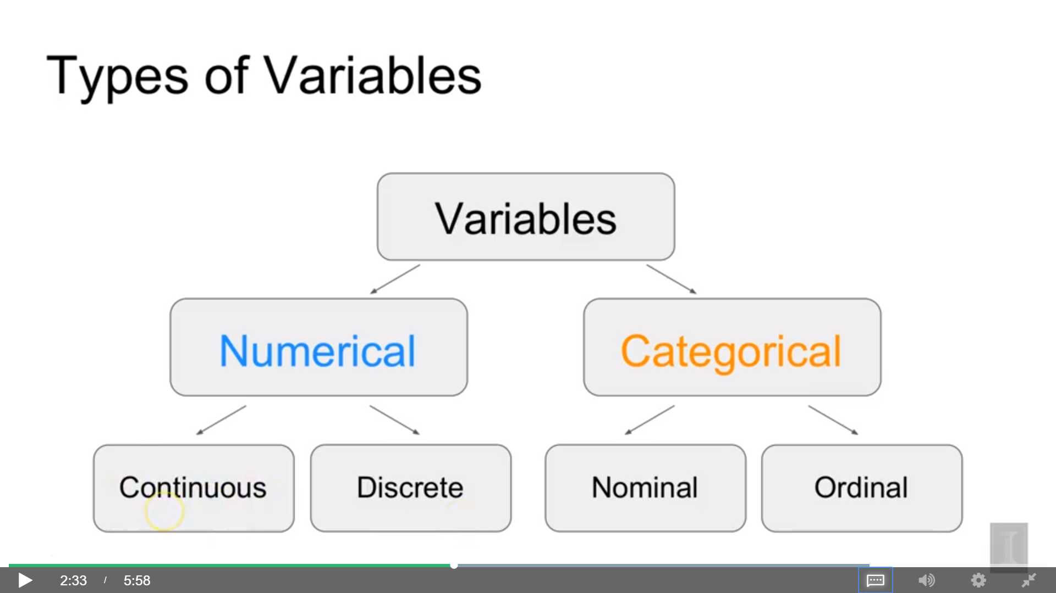

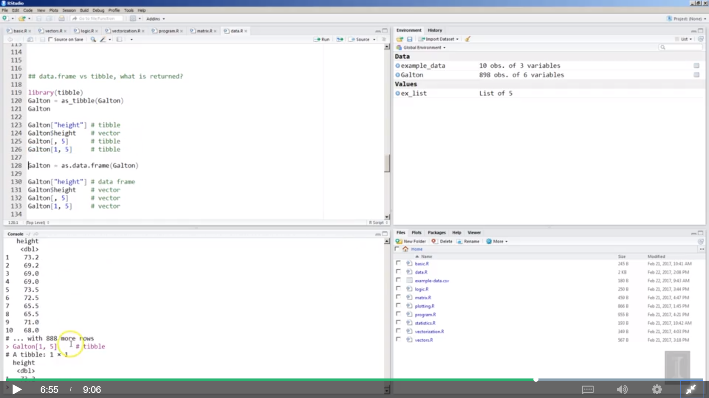

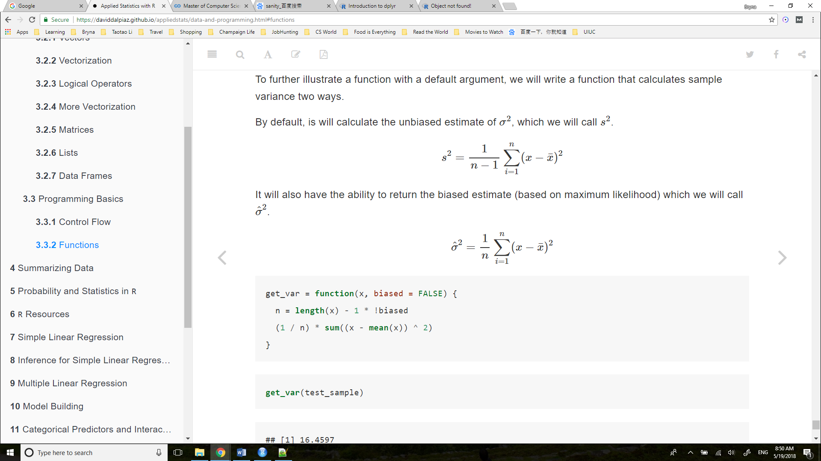

## Solve a matrix

https://www.khanacademy.org/math/precalculus/precalc-matrices/solving-equations-with-inverse-matrices/v/solving-matrix-equation

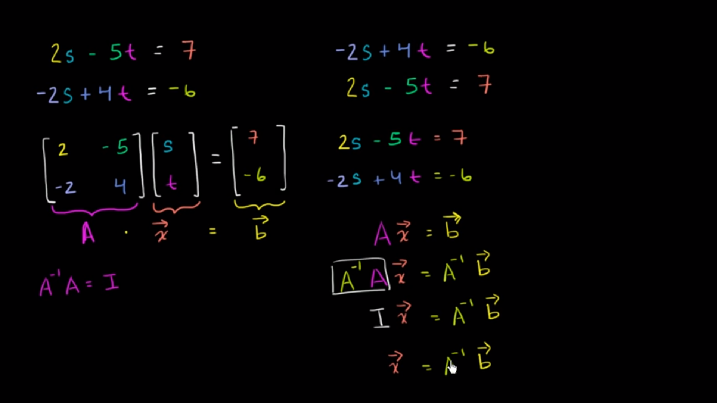

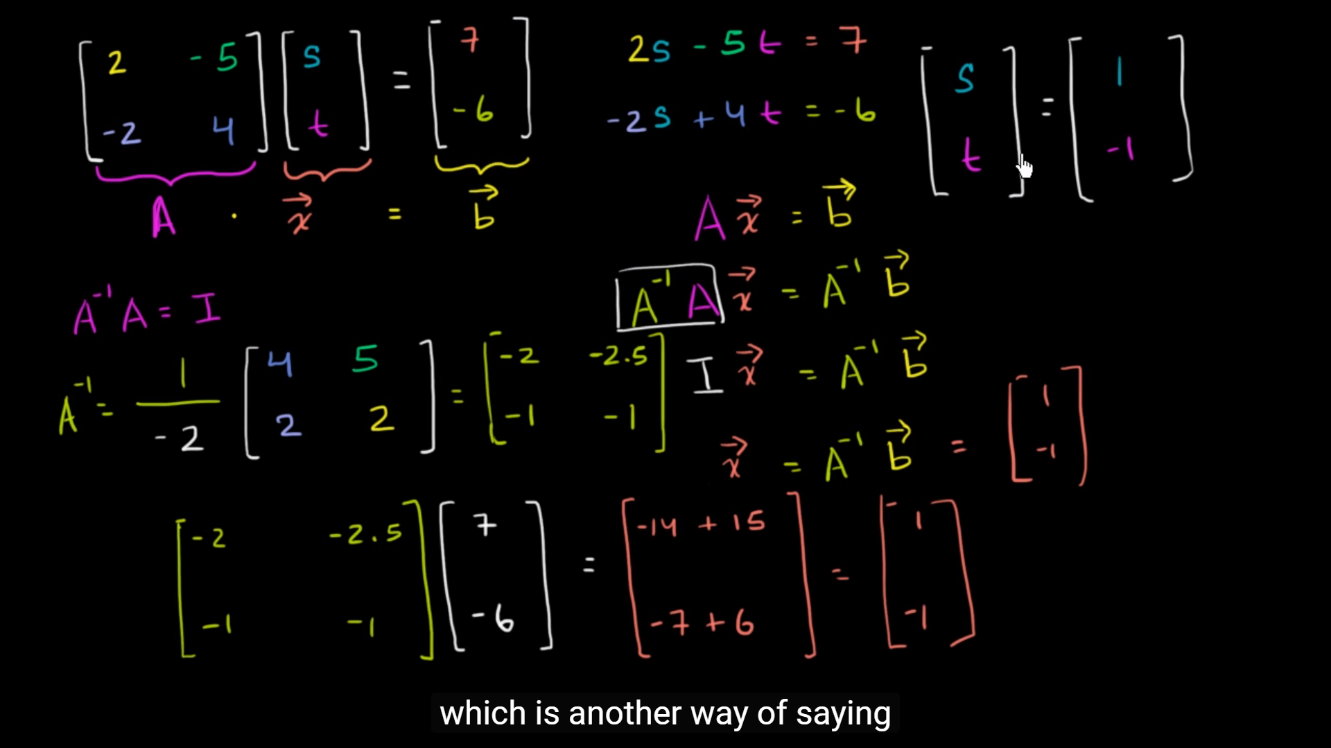

## Inverse of a matrix and Identity Matrix

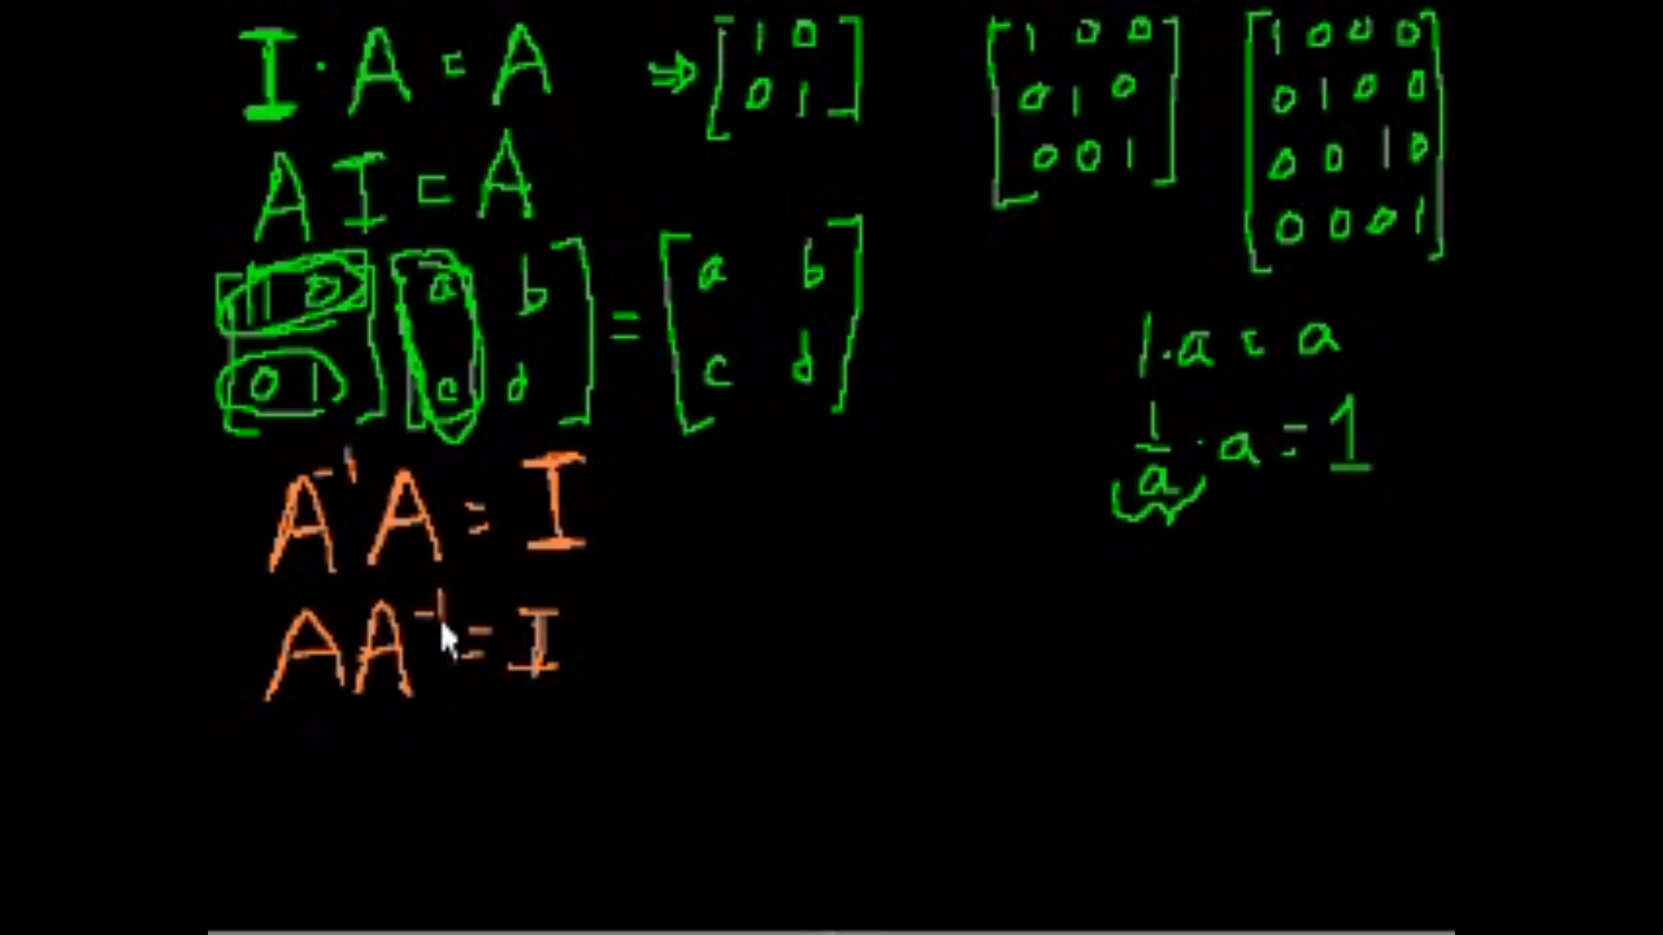

## Transpose of a matrix

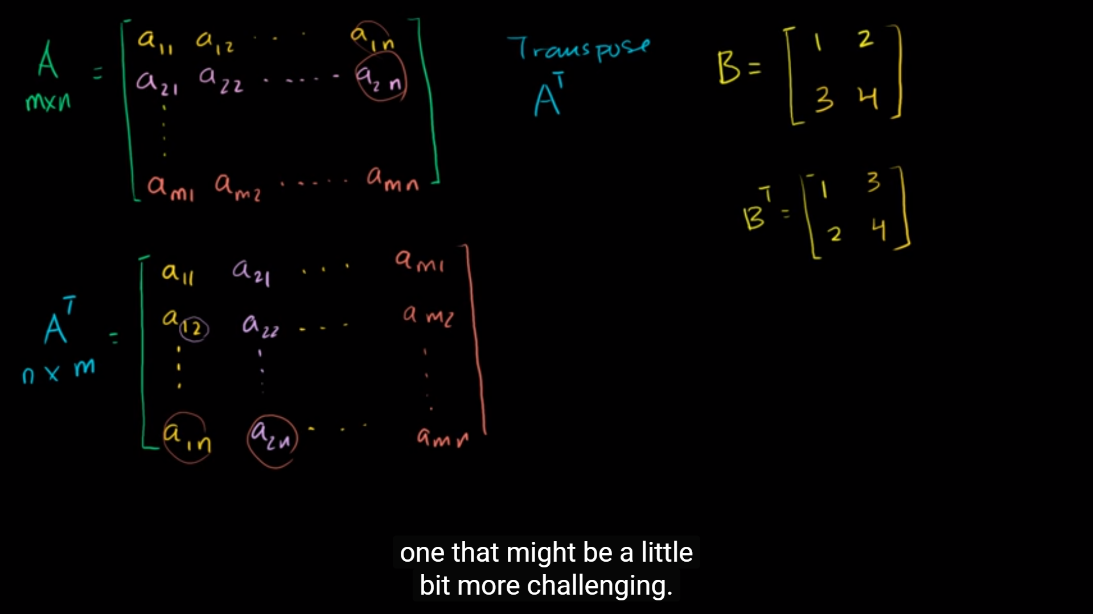

Swap the rows and the columns

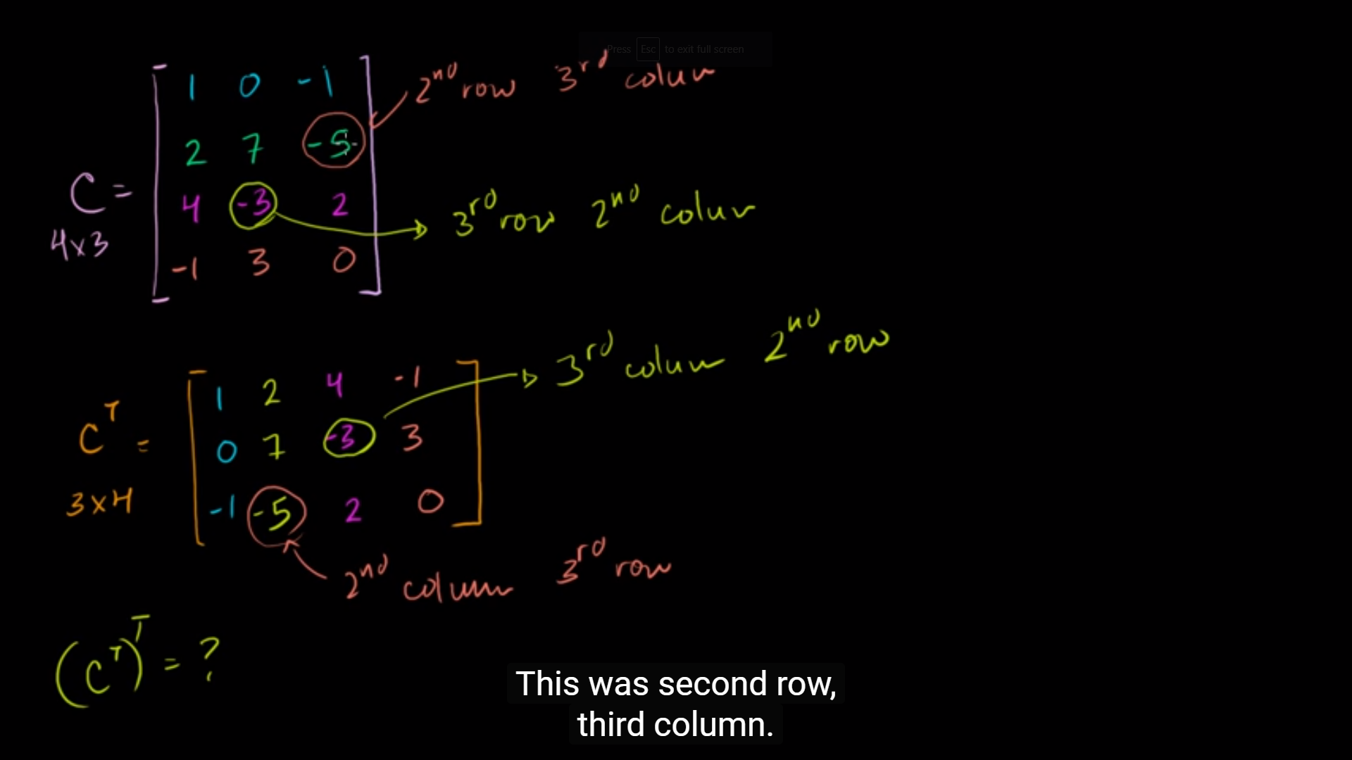

[**https://blog.csdn.net/qq_18343569/article/details/49834099**](https://blog.csdn.net/qq_18343569/article/details/49834099)

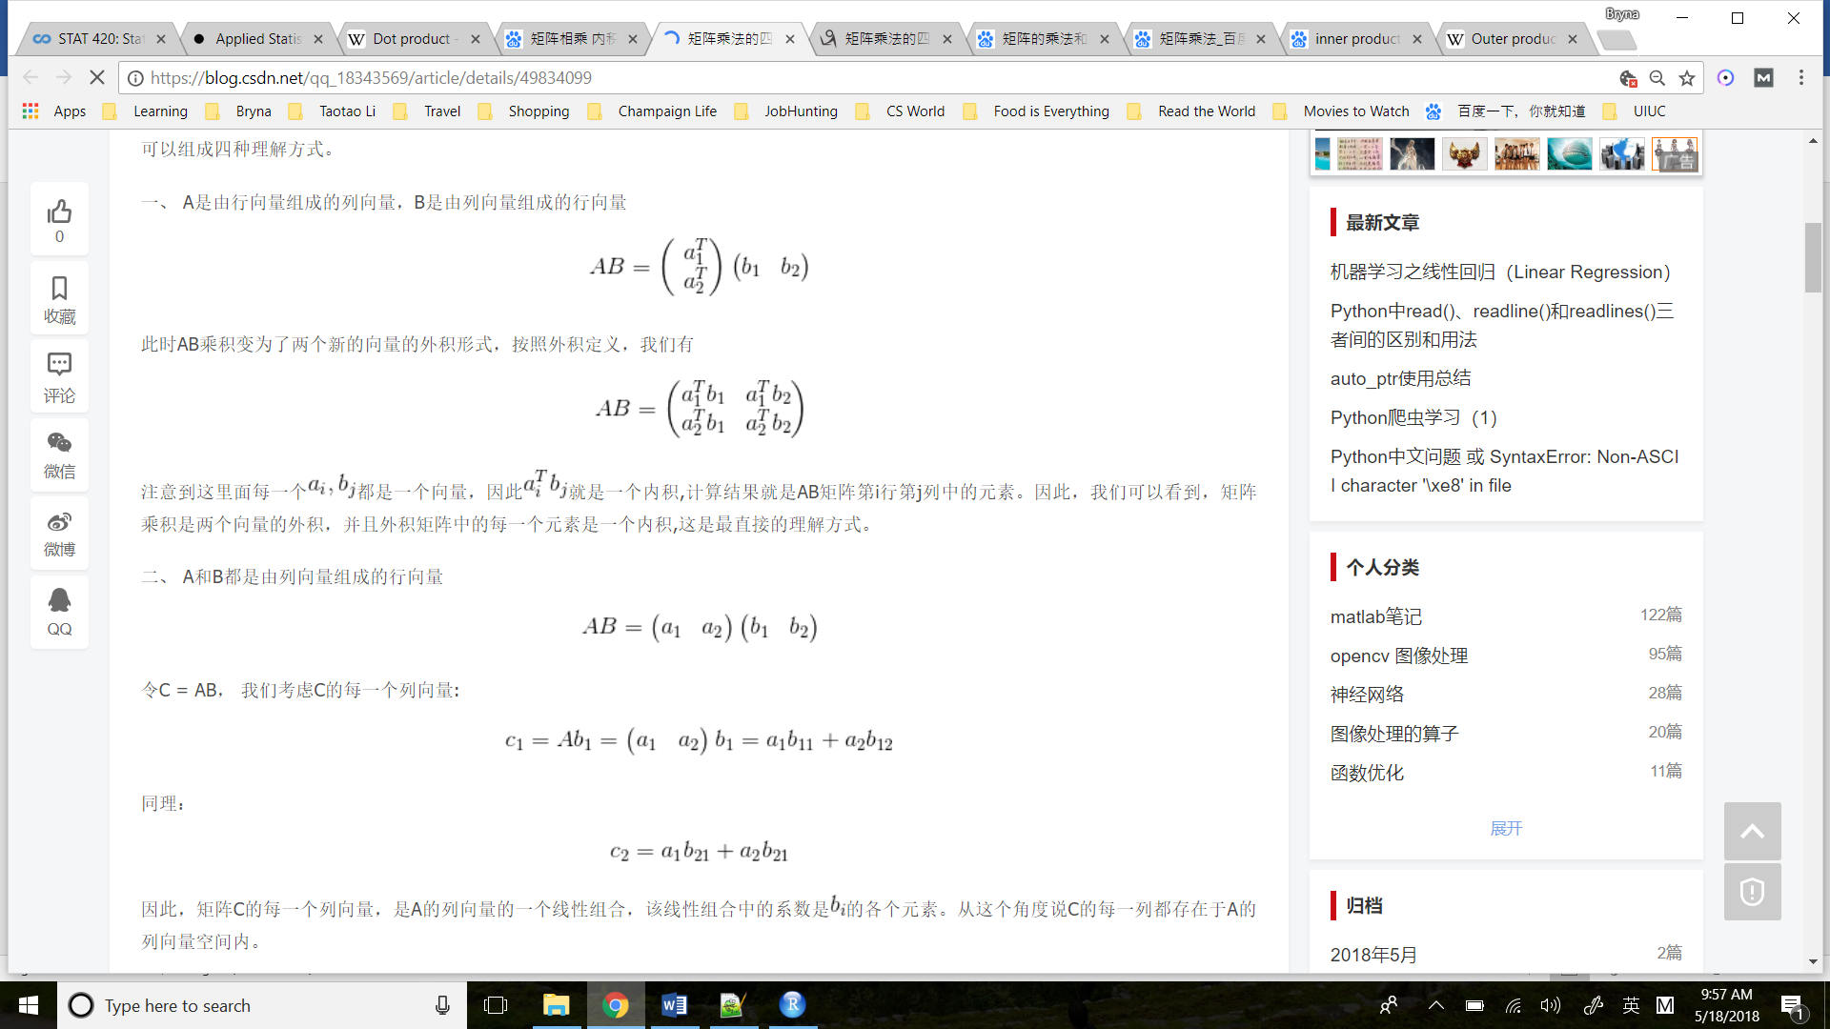

# Week2

Broadly speaking, we would like to model the relationship between X and Y using the form

Y=f(X)+ϵ.Y=f(X)+ϵ.

The function ff describes the functional relationship between the two variables, and the ϵϵ term is used to account for error. This indicates that if we plug in a given value of XX as input, our output is a value of YY, within a certain range of error. You could think of this a number of ways:

* Response = Prediction + Error
* Response = Signal + Noise
* Response = Model + Unexplained
* Response = Deterministic + Random
* Response = Explainable + Unexplainable

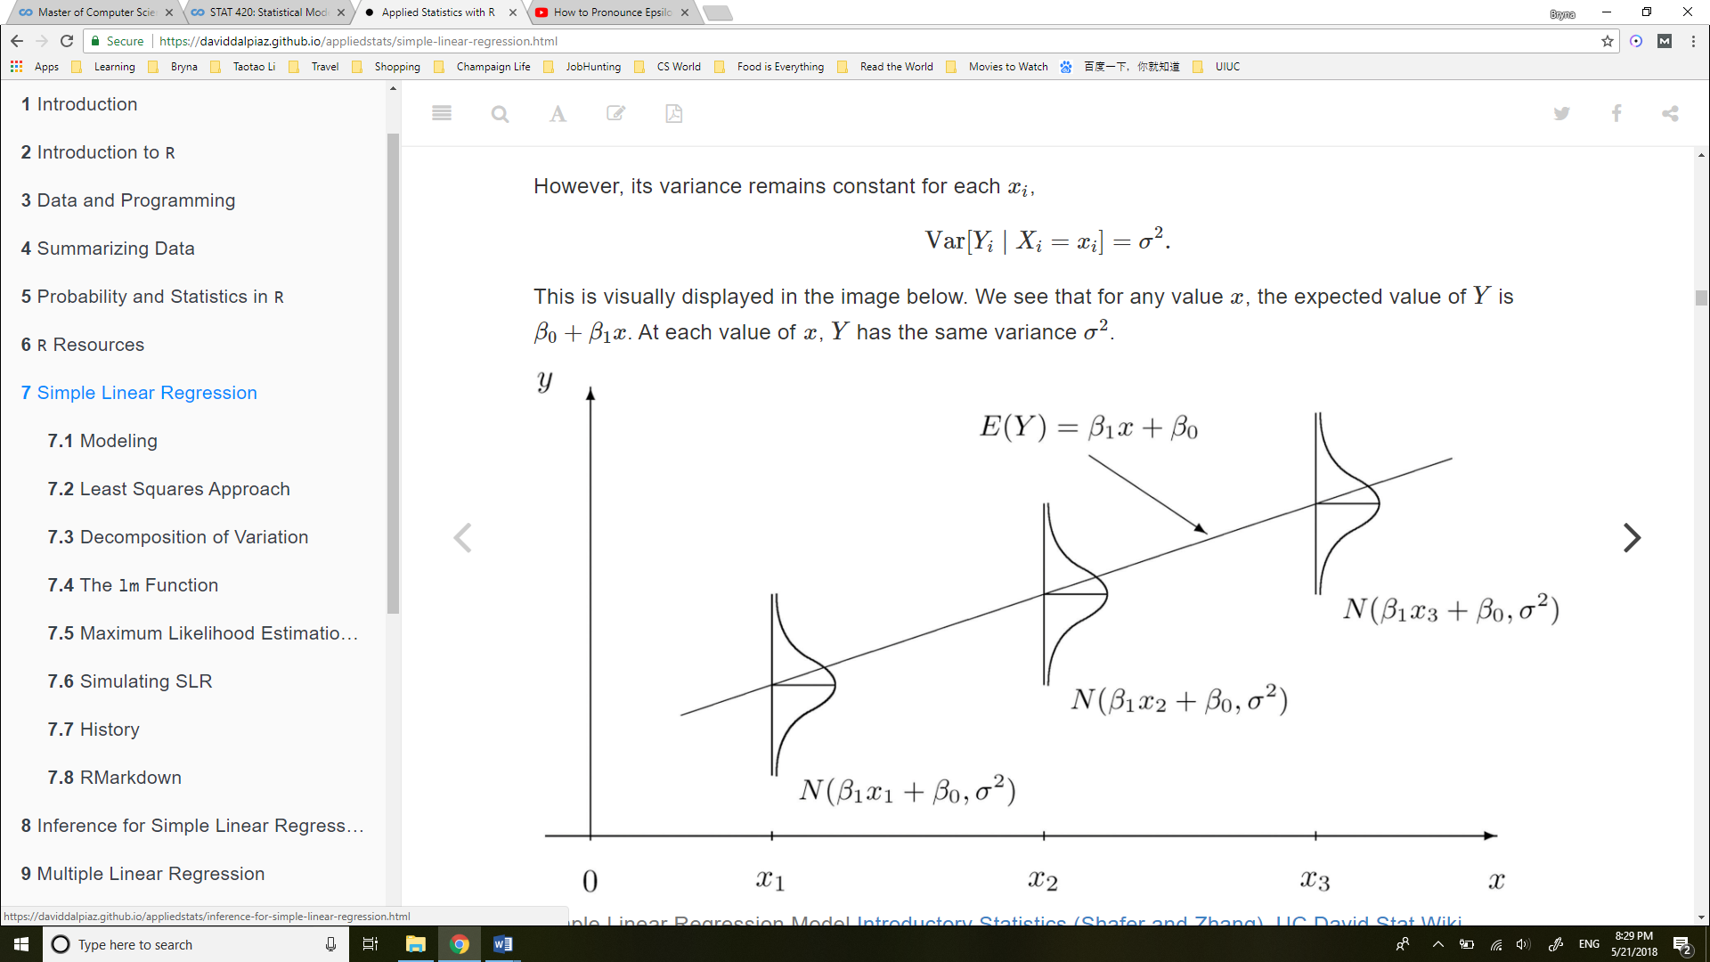

**LINE**.

* **L**inear. The relationship between Y and x is linear, of the form β0+β1x.
* **I**ndependent. The errors ϵ are independent.
* **N**ormal. The errors, ϵ are normally distributed. That is the “error” around the line follows a normal distribution.
* **E**qual Variance. At each value of x, the variance of Y is the same, σ2.

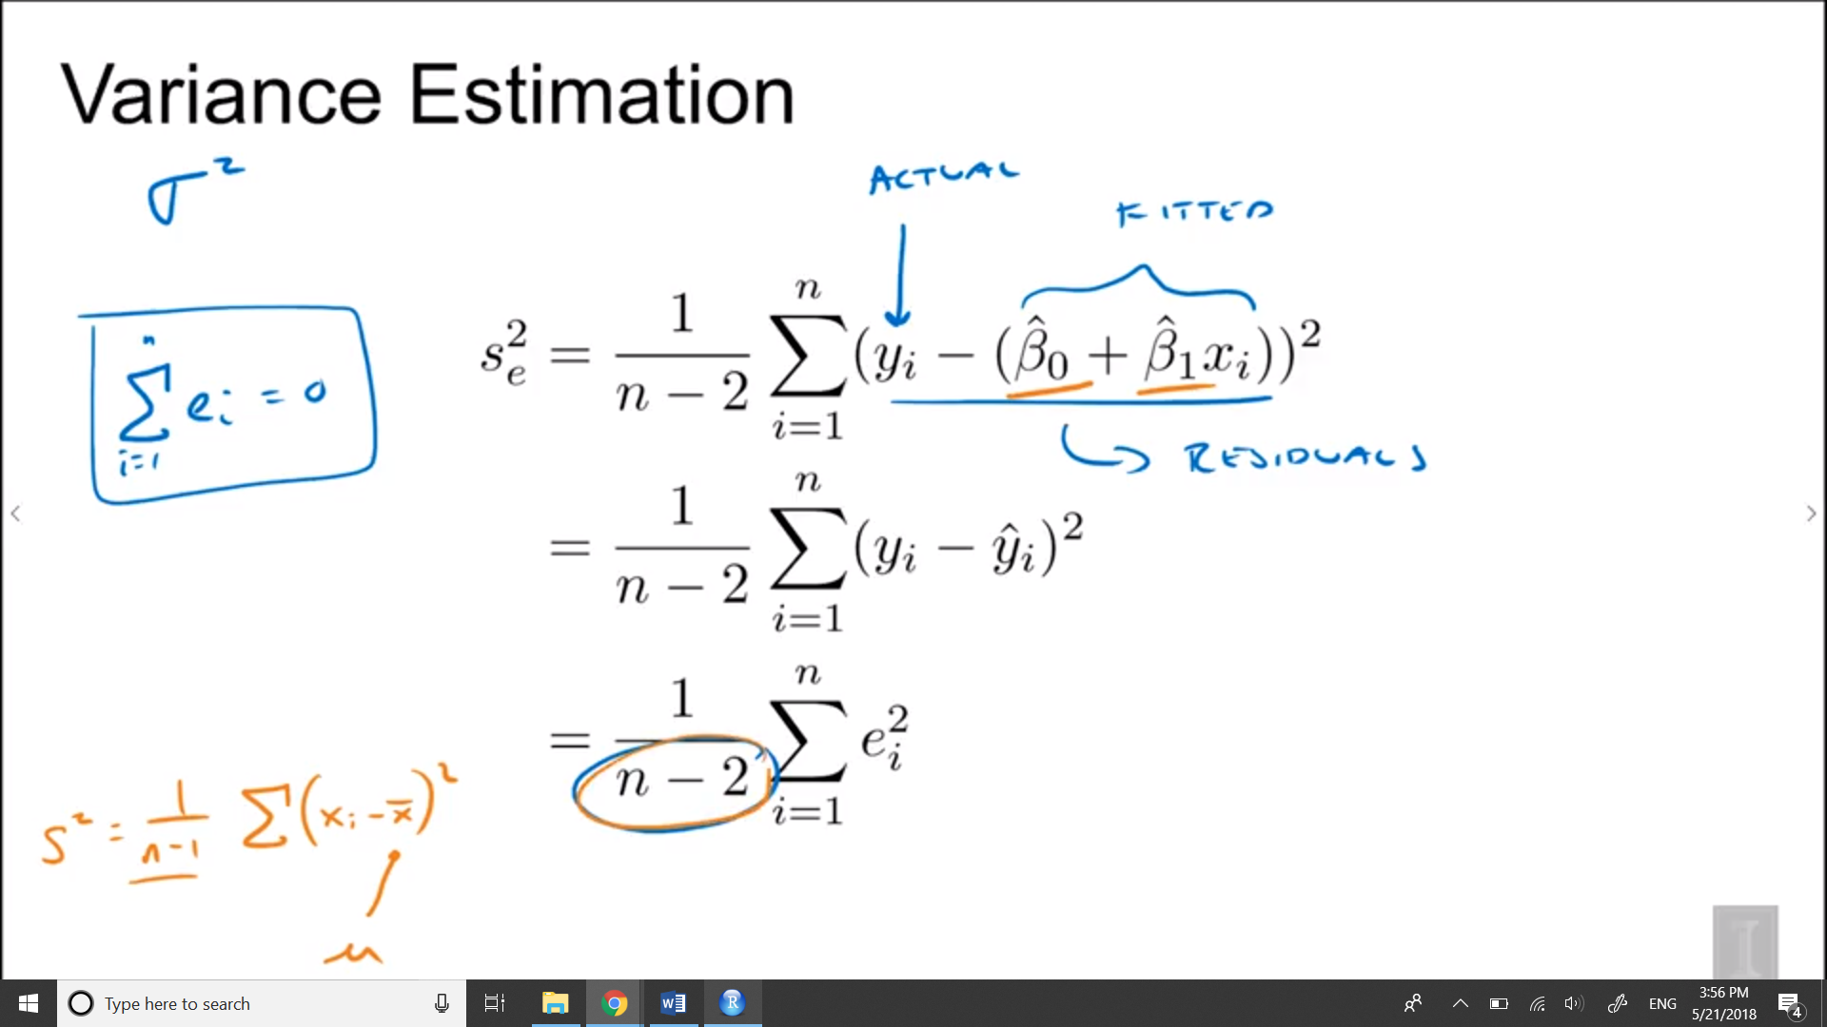

And so here we an n- 1, and that's because this x bar here is an estimate of mu. So we estimate one parameter, so we say we lose a degree of freedom. So we had to divide by n- 1, so that's similar to why we had to divide by n- 2 here. Because we had to estimate two parameters before calculating the estimate of the variance

## 7.2 Least Squares Approach

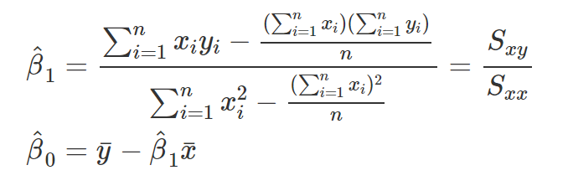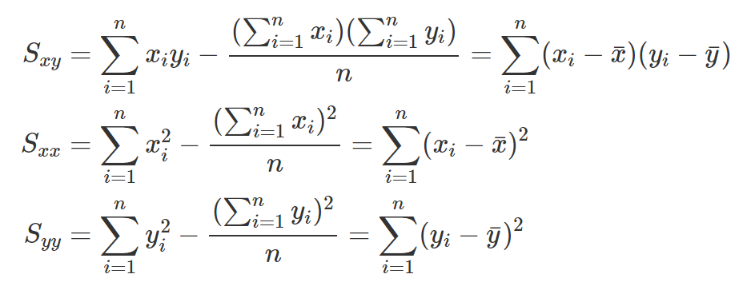

#### Sum of Squares Total

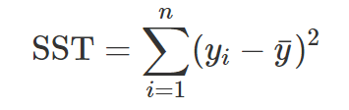

#### Sum of Squares Regression

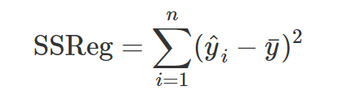

#### Sum of Squares Error

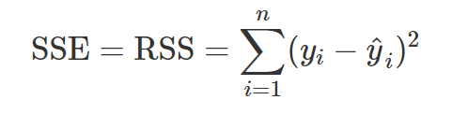

“Sum of Squares Error,” SSE, represents the **unexplained variation** of the observed y values. You will often see SSE written as RSS, or “Residual Sum of Squares.

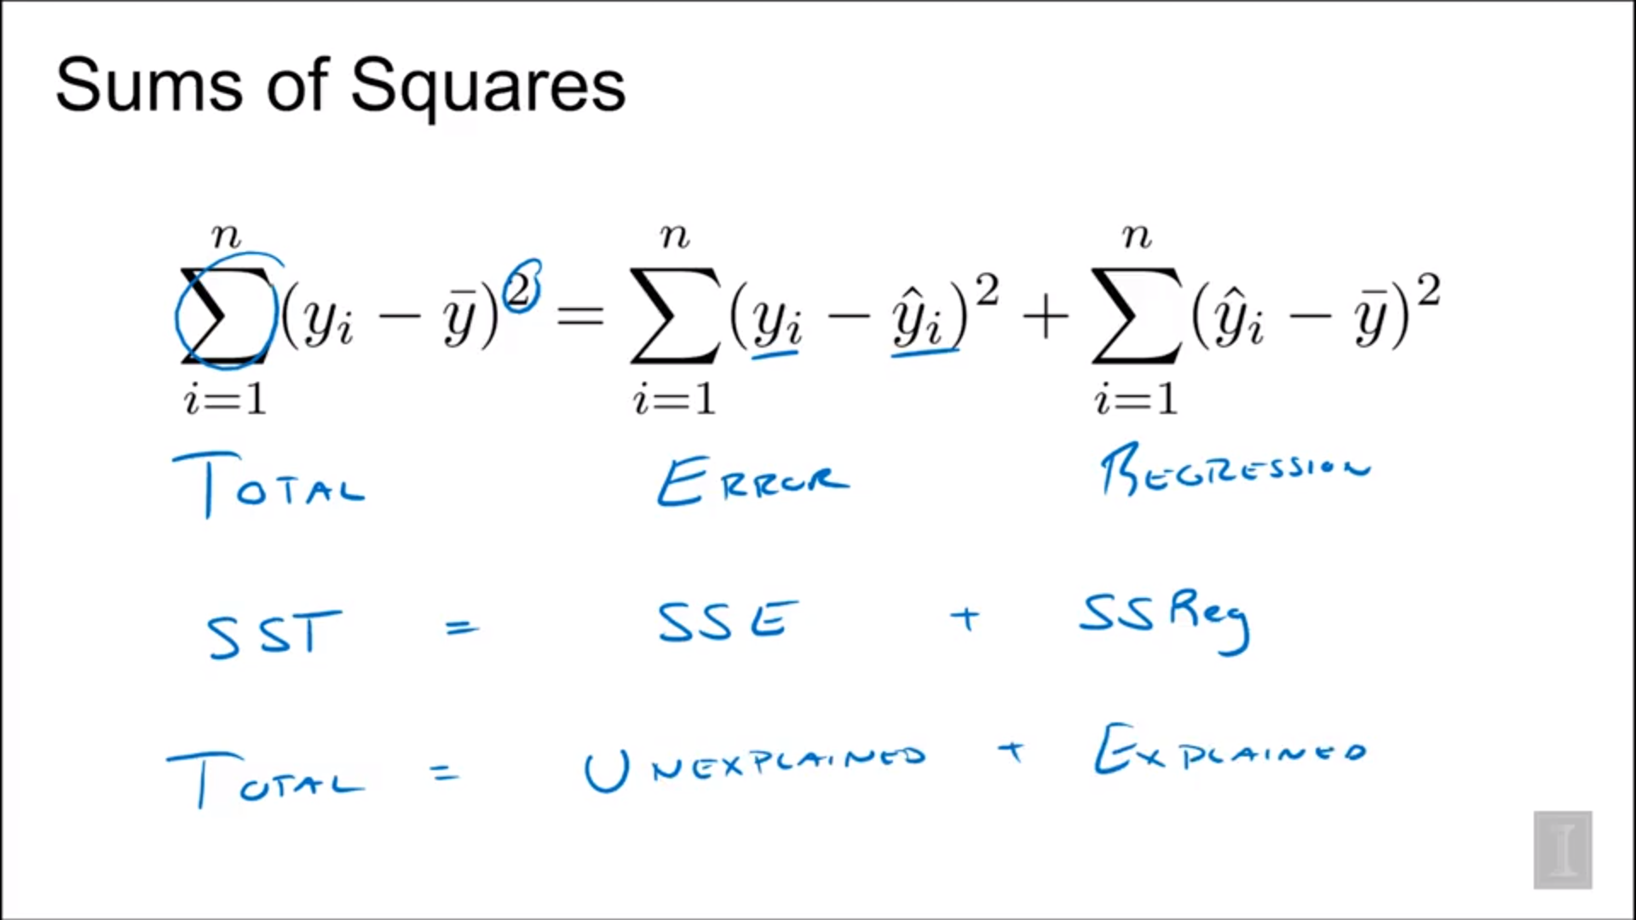

### Coefficient of Determination

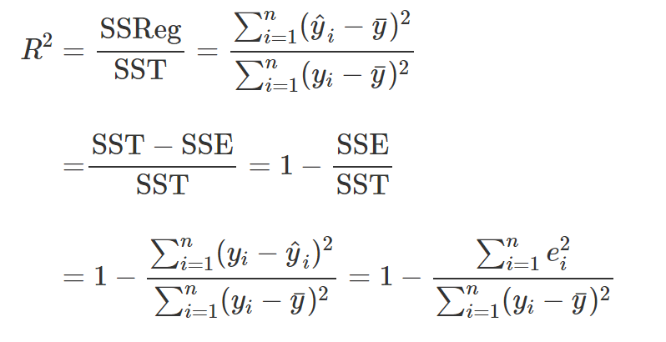 SSE = SEline, SST = SEy

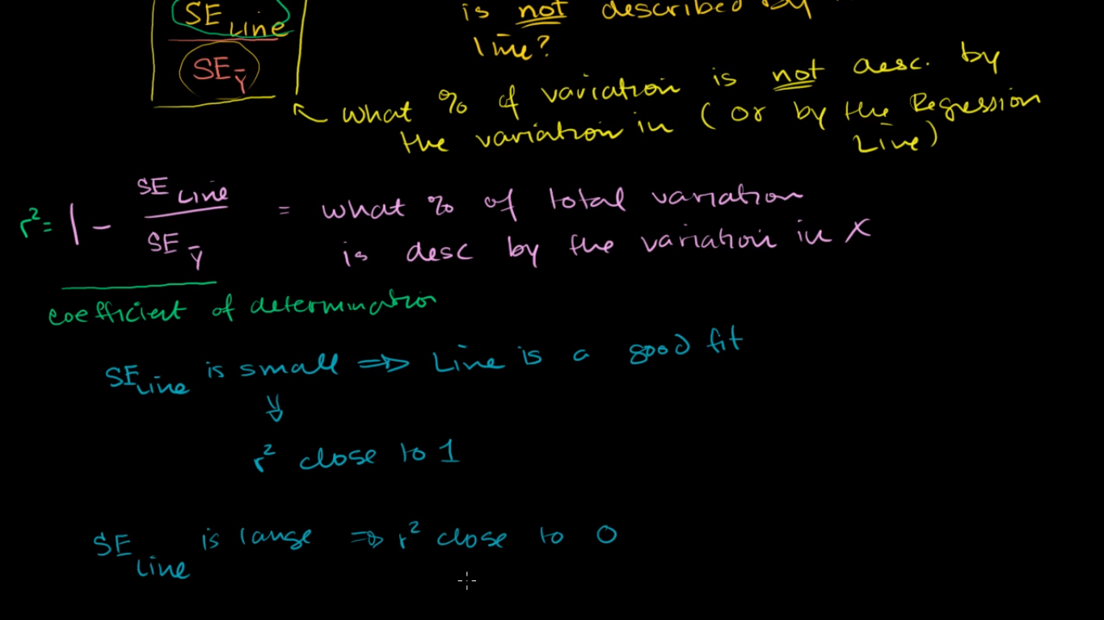

the regression makes up a much larger portion of the total line than the error does

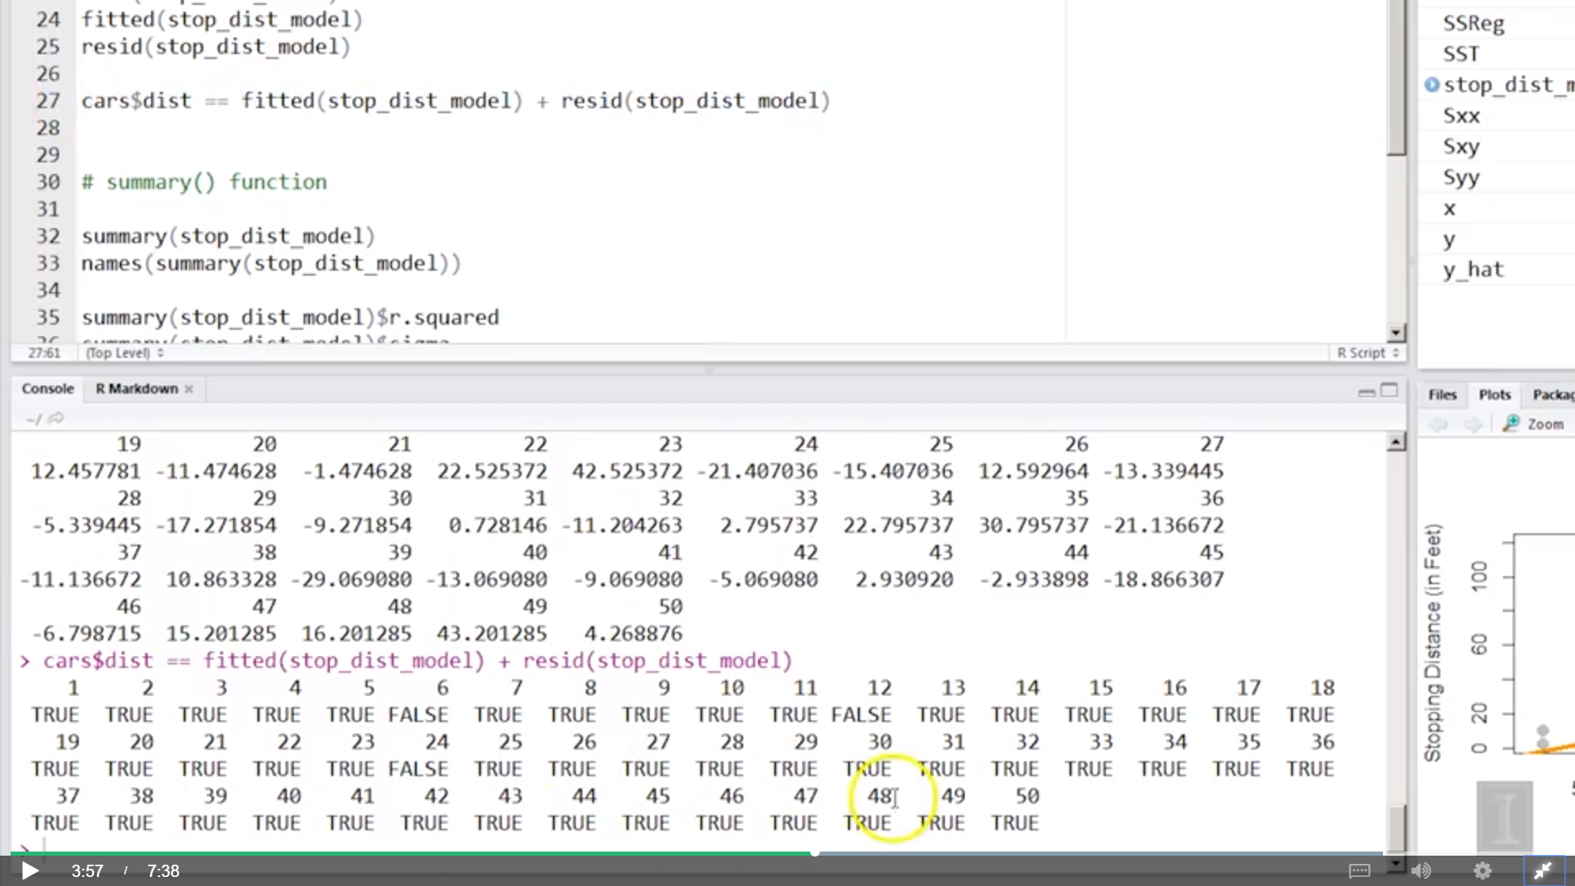

## Probability vs Likelihood

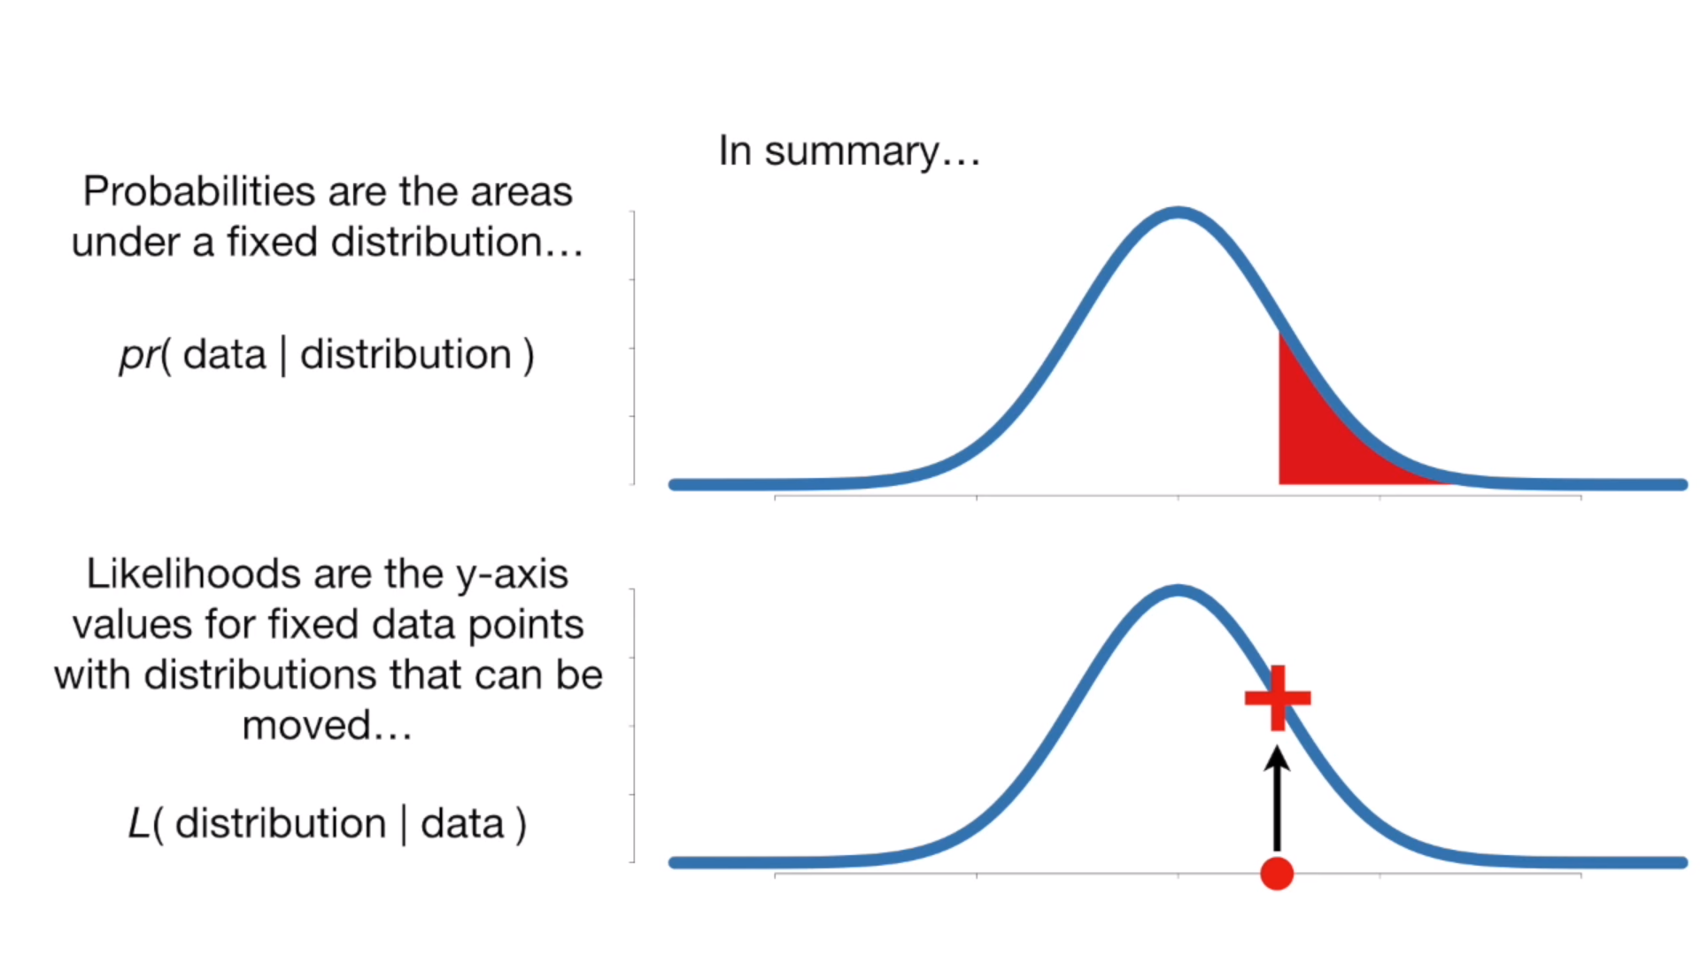

## 7.5 MLE

# Week3

## 8.1 Gauss–Markov Theorem

The **Gauss–Markov theorem** tells us that when estimating the parameters of the simple linear regression model β0 and β1, the β^0 and β^1 which we derived are the **best linear unbiased estimates**, or BLUE for short.

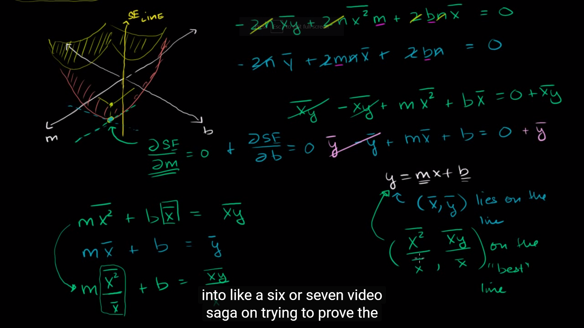

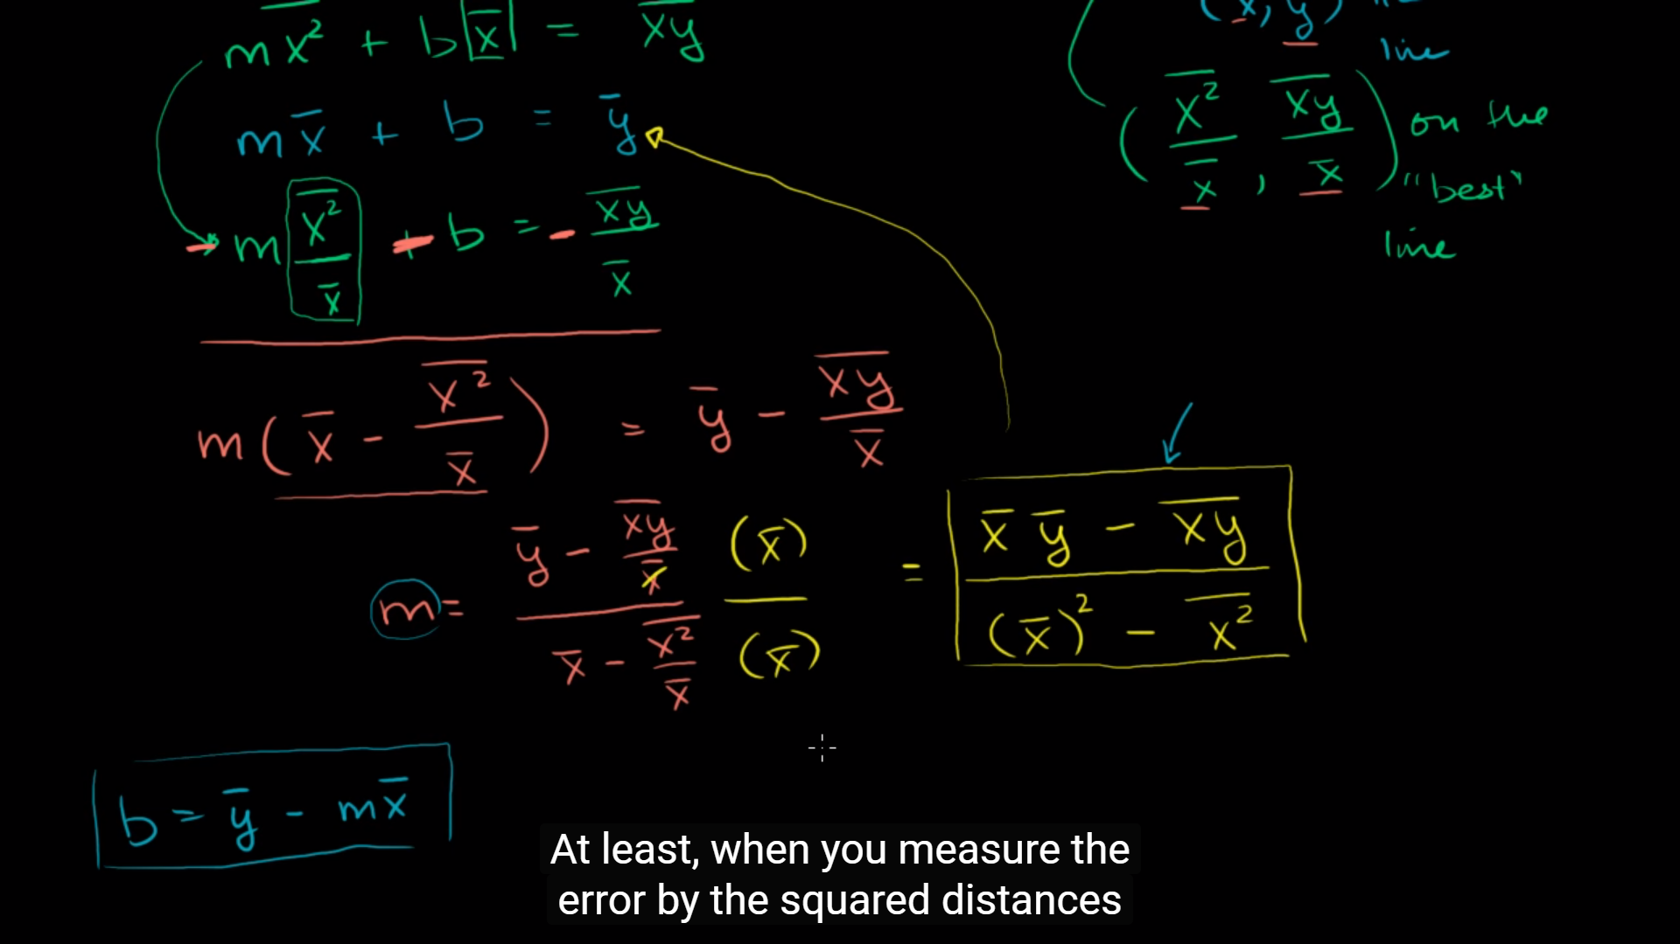

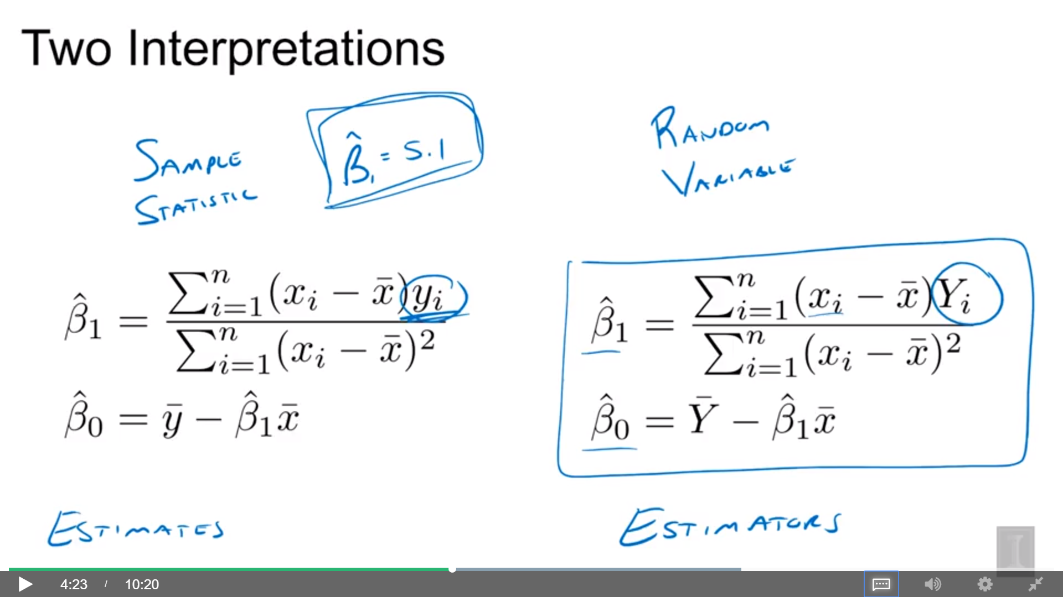

Sample vs Random Variables

Estimates vs Estimators

An estimate is a particular value of an estimator for a given dataset. So when you apply the estimator to a dataset, you get an estimate.

z-score vs t-score

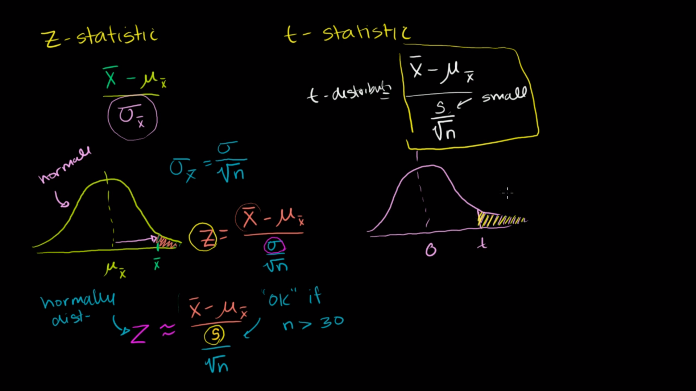

## 8.3 Standard Errors

Standard normal, mean = 0, variance = 1

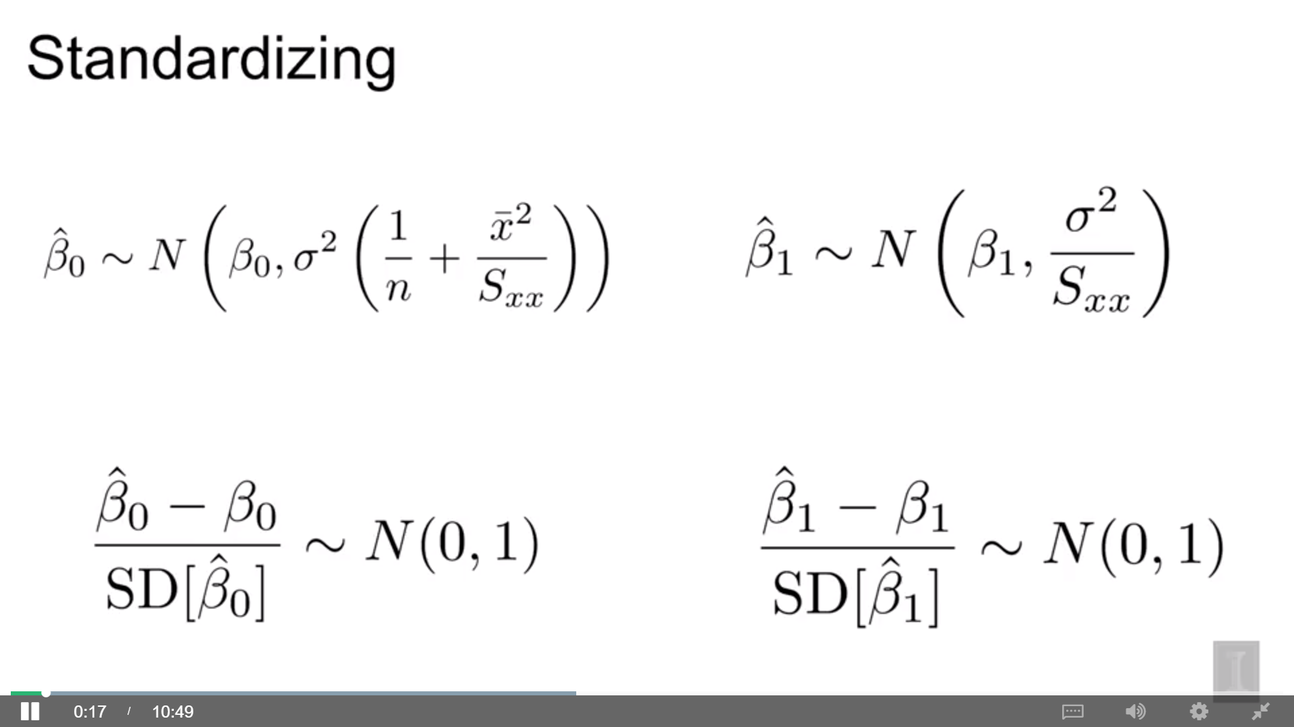

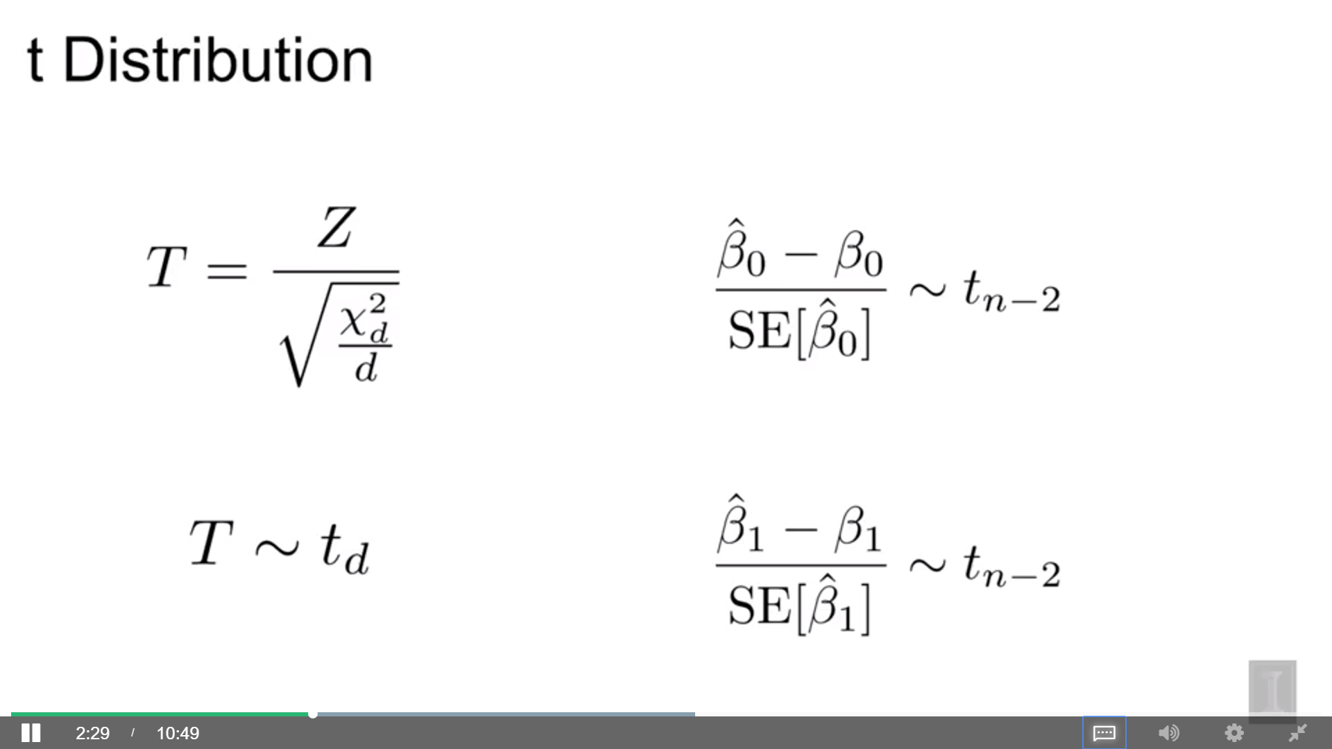

after doing this new standardization procedure where we divide by the standard error instead of standard deviation.

If we have a random variable t and it’s a ratio of on top, Z (a standard normal random variable) and on the bottom, the square root of a chi-squared distribution with d degrees of freedom divided by d, it follows a t distribution with d degrees of freedom

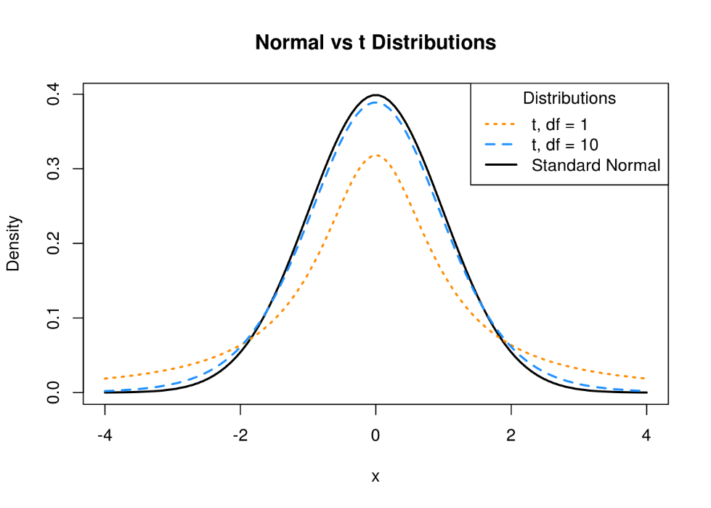

A t distribution with any degrees of freedom: mean = 0, symmetric

A t distribution is similar to a standard normal, but with heavier tails, a normal distribution has more of its density closer to the mean while t distributions are more spread out

How spread out is dependent on their degrees of freedom: as degrees of freedom increases, the tail has less of density and more of it is closer to zero and become more like a standard normal distribution

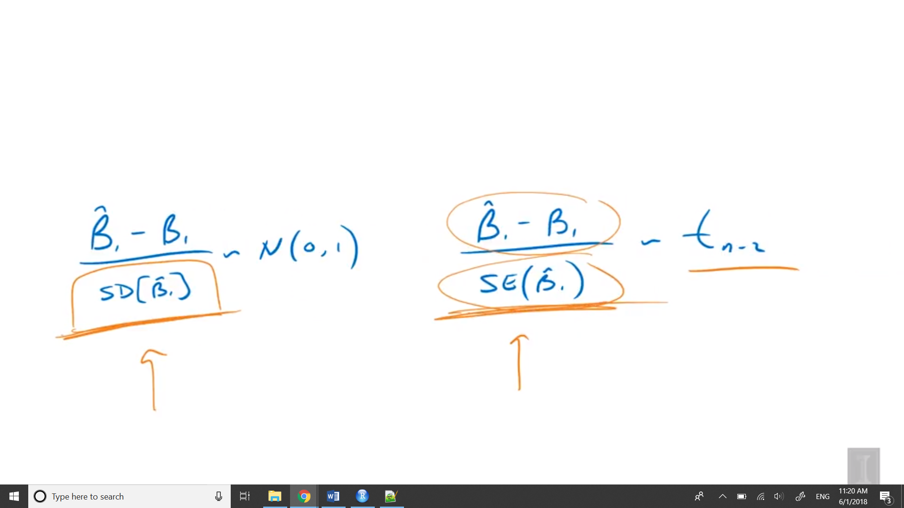

Since we’re using standard error, it’s becoming more variable

As the sample size grows, the degrees of freedom grow and t distribution become closer to the standard distribution

## 8.4 Confidence Intervals for Slope and Intercept

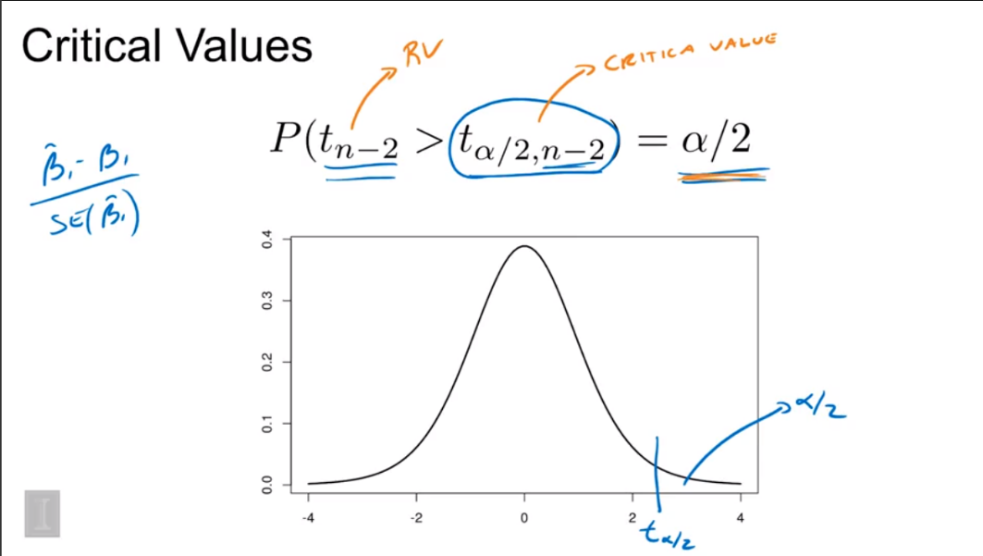

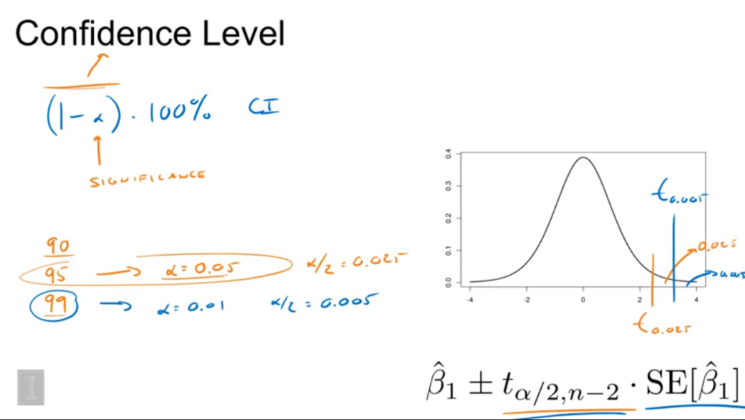

Higher confidence level needs larger interval (blue)

The width of the interval is based on two things:

1. Standard error, we don’t control
2. Critical value, have some control via the confidence level

We are 99% confident that the true change in mean stopping distance for an increase in speed of one mile per hour is between 2.81 and 5.05

## Mean response

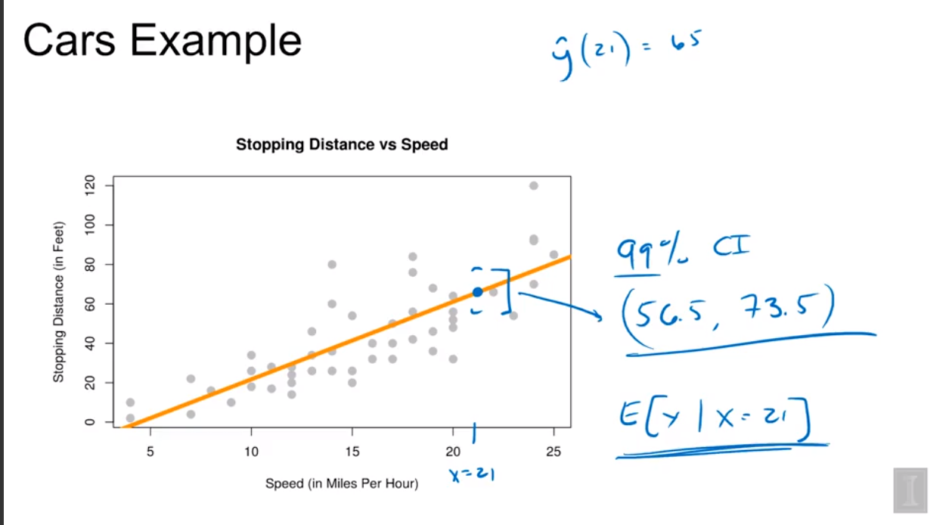

The further away from the sample mean of x, the larger the standard error is going to be.

The mean of y that is the stopping distance when x is 21.

This interval is for the mean of y, capturing is where we think this regression line would be for an x of 21, not all the potential observations for x of 21.

## Prediction Intervals

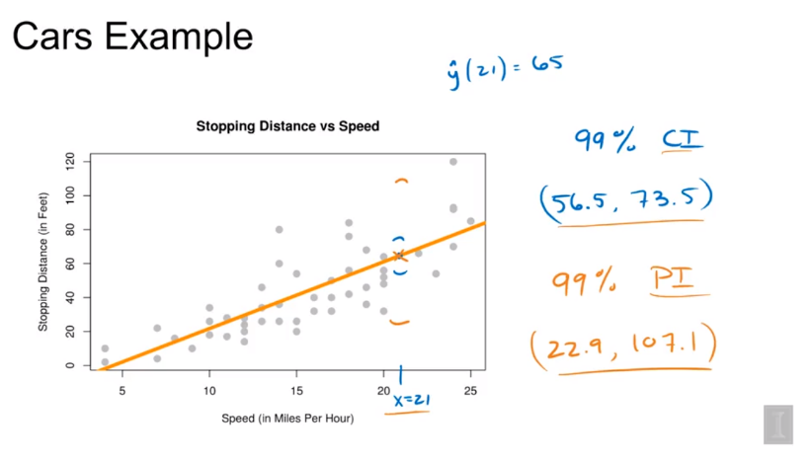

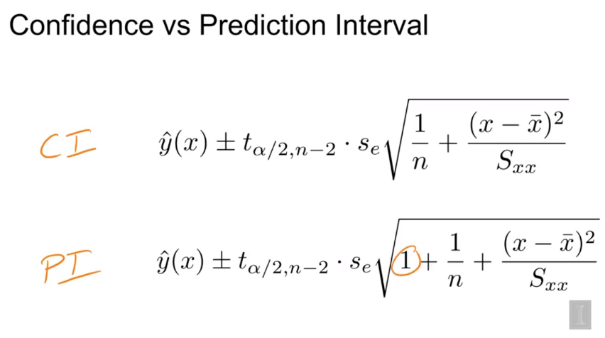

Also, both intervals are at its narrowest when we’re predicting at x bar and the further we get away, the wider the interval gets, since there’s less data near the points that we’re predicting at.

## 8.5 Hypothesis Tests

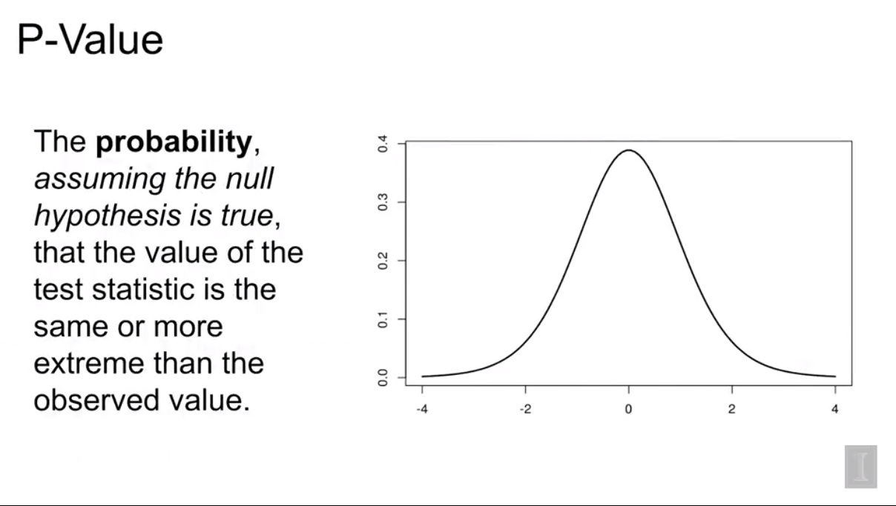

1. Test for whether or not we need to use a line to model the data ( H0: there is no significant linear relationship between x and y)

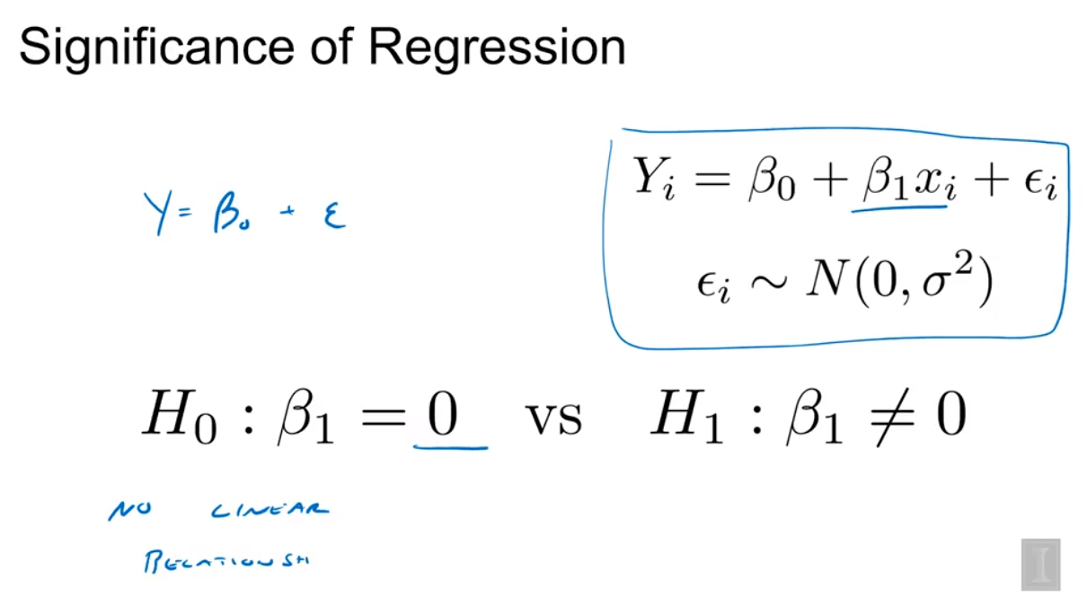

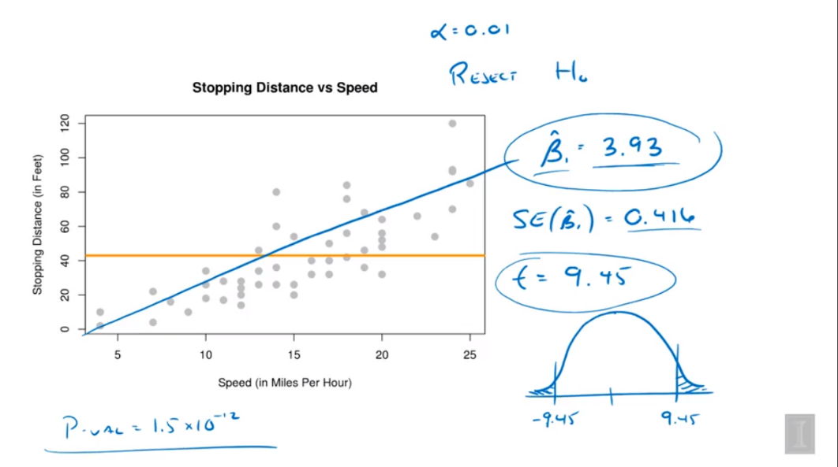

p-value < 0.01, reject H0 => there is a linear relationship

1. Confidence Interval

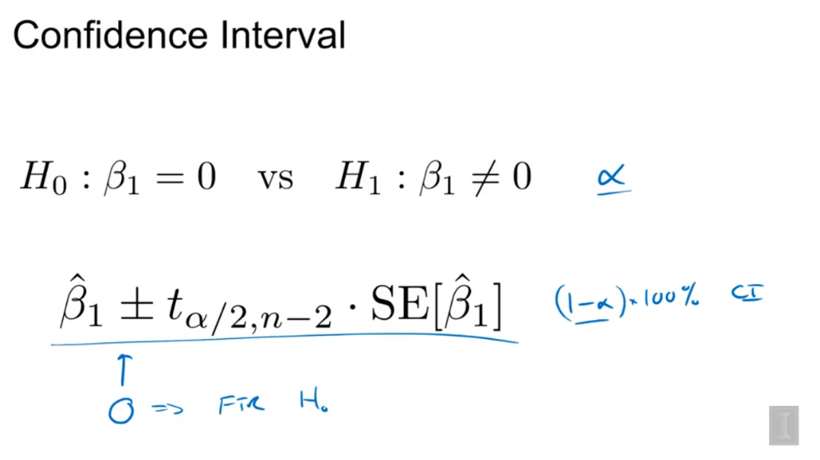

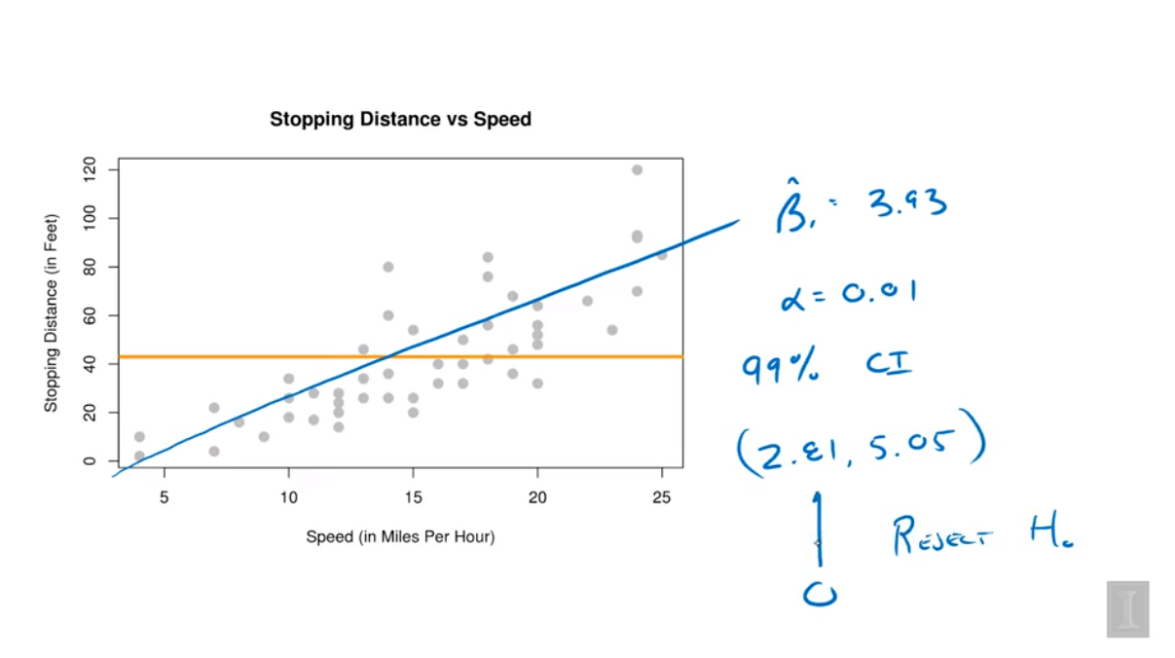

0 is outside of the interval => reject H0

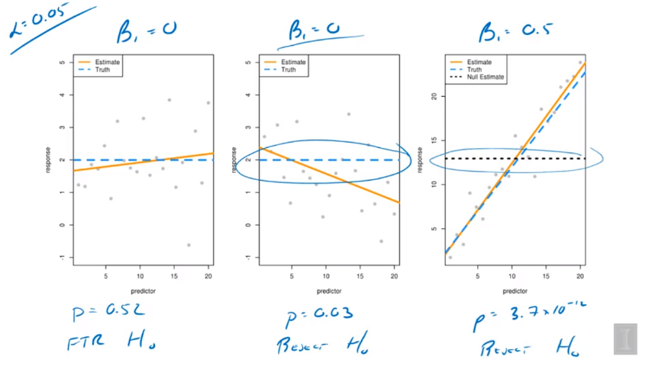

1. P = 0.52 > 0.05, fail to reject H0 => no linear, correct
2. P = 0.03 < 0.05, reject => linear, wrong
3. P = 3.7 * 10-12 < 0.05, reject => linear, correct

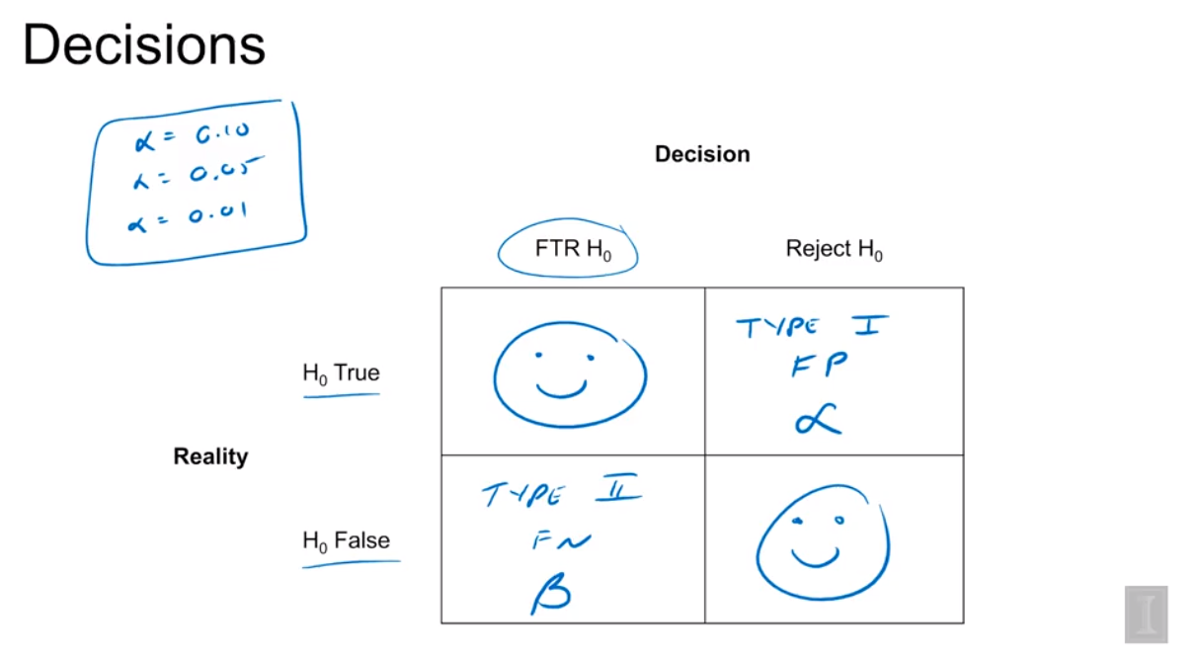

Type 1 Error: just like Pic2, reject a True H0, there is no relationship, control alpha

Type 2 Error: fail to reject a False H0, there is relationship, beta

# Week4

## Interpreting the MLR Model

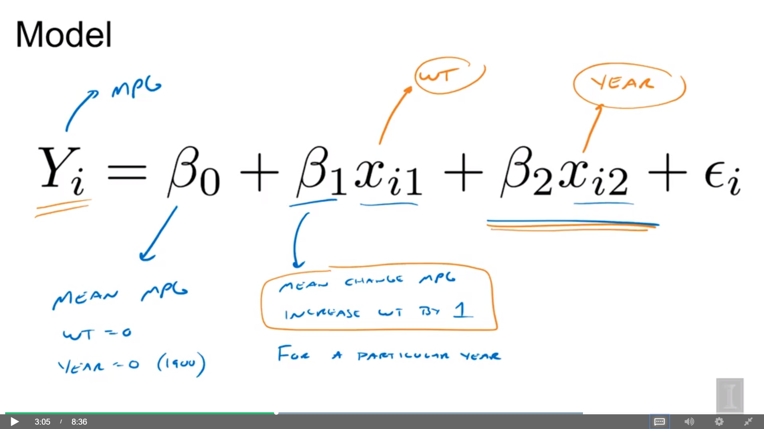

So, first, we could talk about the beta_0, which is the mean miles per gallon, so it's the average fuel efficiency when the weight is zero, that is, zero pounds and the year is zero, and that would actually correspond to the year 1900. Again, this is an average because we're dealing with estimating means with this model. But in particular, beta_0 is a particular mean when weight is zero and year is zero. Now, this is a quantity that we're not all that interested in. The more interesting model parameters are beta_1 and beta_2. They tell us how weight and year affect the response miles per gallon. Focusing on beta_1, beta_1 tells us how Y changes when x_1 changes. It's the mean change in miles per gallon when you increase the weight by a pound but in a particular situation, that is, for a particular year. So, here, would have been the interpretation under the simple linear regression model. But now, we have this extra predictor and, thus, parameter in the model. Year is explaining some of the fuel efficiency and weight is also explaining some of the fuel efficiency. When we increase the weight by one, that's beta_1 is how much Y increases. But we have to consider that year is already in the model, so it's for a particular value of year. Beta_2 then has a similar interpretation. It's the main change in fuel efficiency when you increase year by one for a particular value of weight

## F Statistic

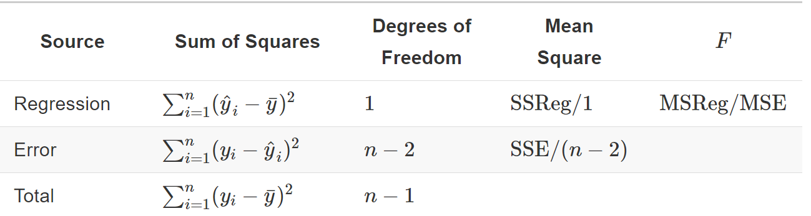

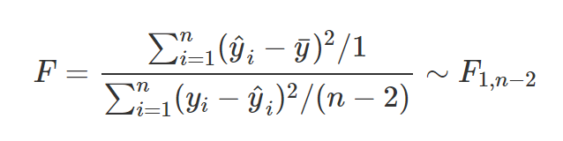

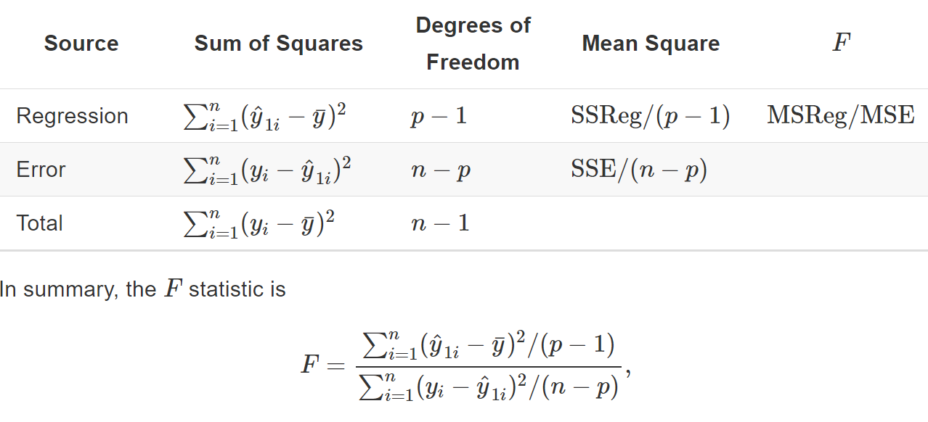

If q = 1

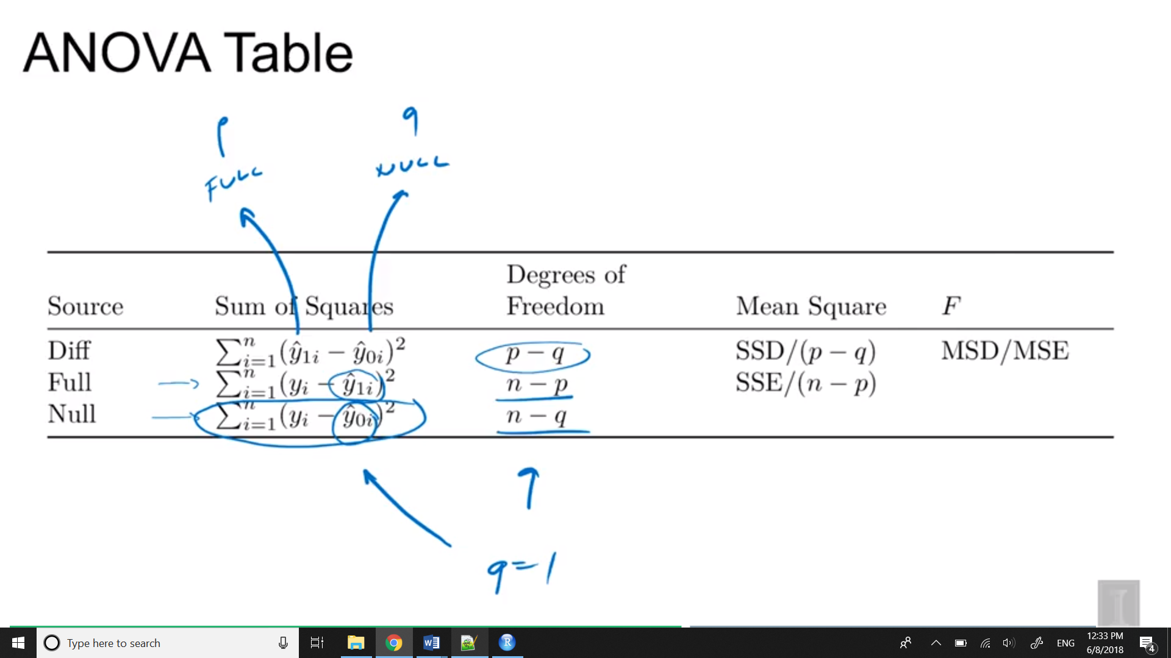

When f-statistic is small, full model similar to the null model => fail to reject => prefer small model

Large, when they’re far apart => reject H0 => prefer large model

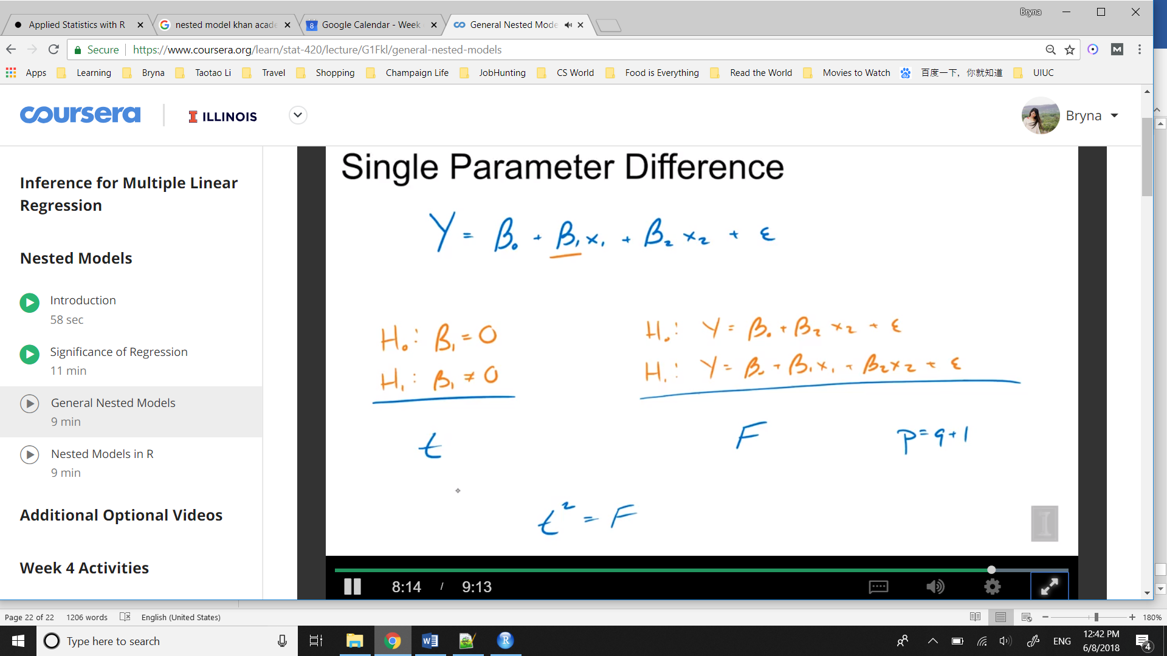

T2 = F and same p-value

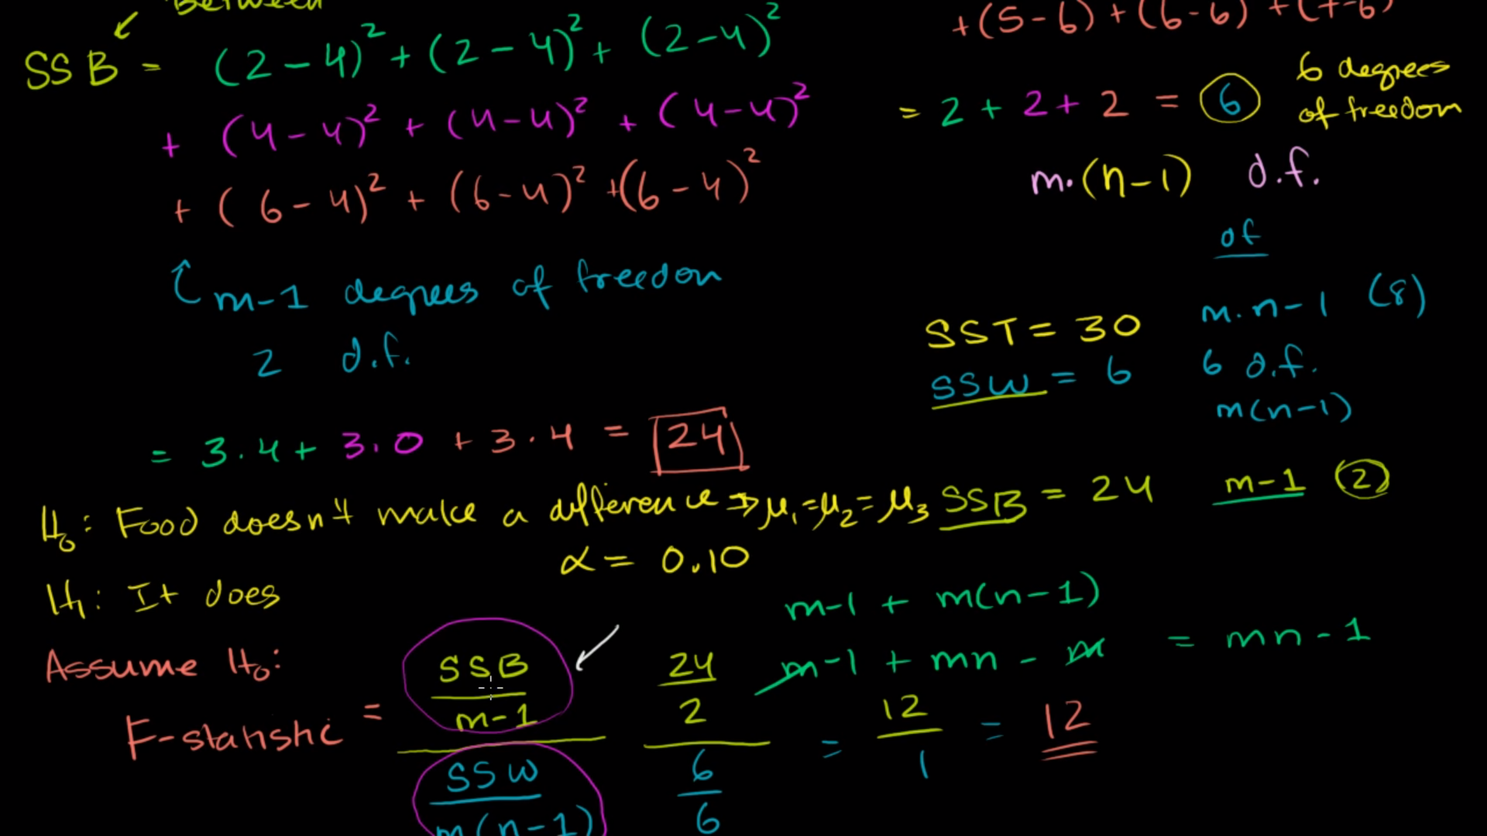

F is large ( regression > error) => p is small => reject H0 => there is linear relationship

# Week7

# 10 Model Building

Fitting a model only gives us the best fit for the family and form that we specify. So the natural question is; how do we choose the correct family and form? We’ll focus on form since we are focusing on the family of linear models.

What is the purpose of fitting a model to data? Usually it is to accomplish one of two goals. We can use a model to **explain** the relationship between the response and the predictors. Models can also be used to **predict** the response based on the predictors.

with our inference tools (ANOVA and t-test) we have two potential strategies. Start with a very small model (no predictors) and attempt to add predictors. Or, start with a big model (all predictors) and attempt to remove predictors.

Models can be used to **explain** relationships and **predict** observations.

When using model to,

* **explain**; we prefer *small* and *interpretable* models.
* **predict**; we prefer models that make the smallest errors possible, without *overfitting*.

Linear models can accomplish both these goals. Later, we will see that often a linear model that accomplish one of these goals, usually accomplishes the other.

## 11.1 Dummy Variables

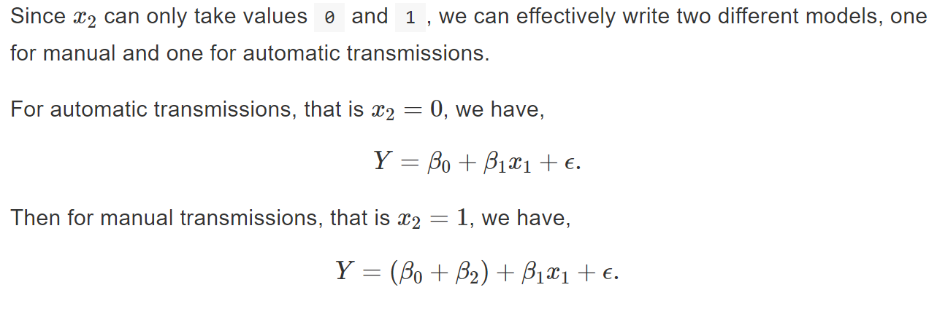

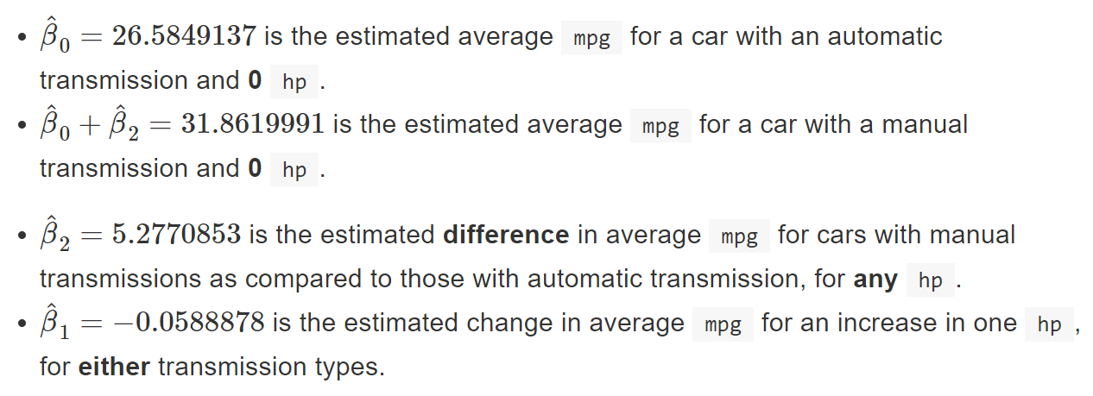

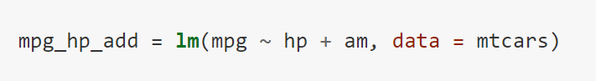

## 11.2 Interactions

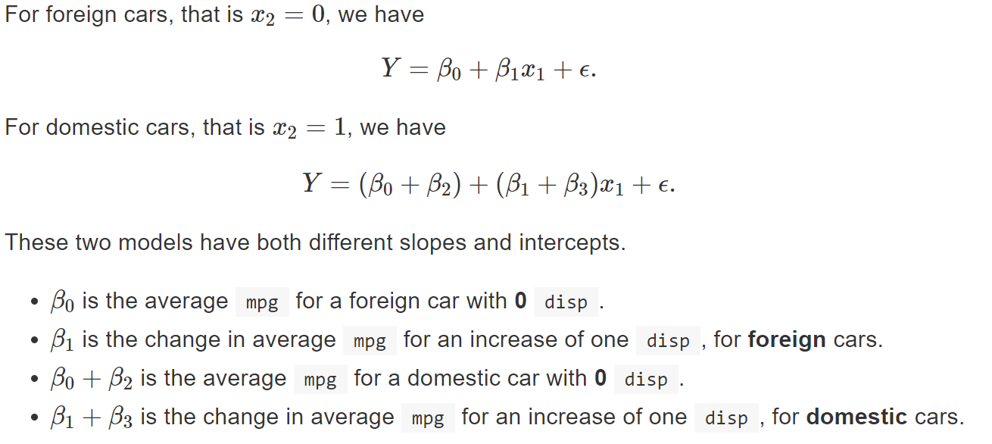

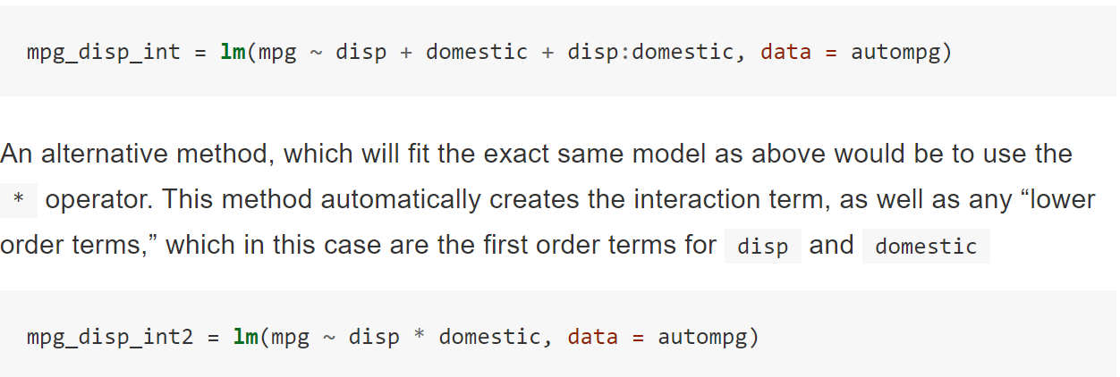

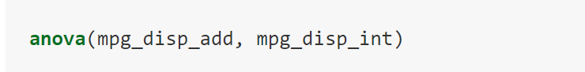

### Numeric and Numeric

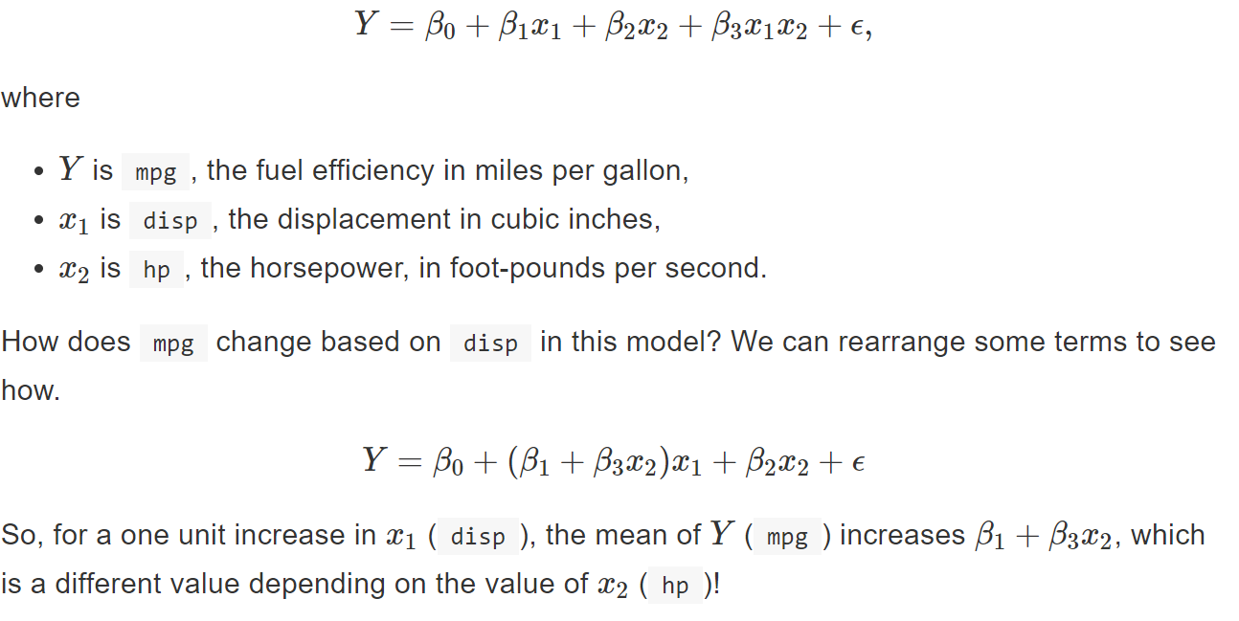

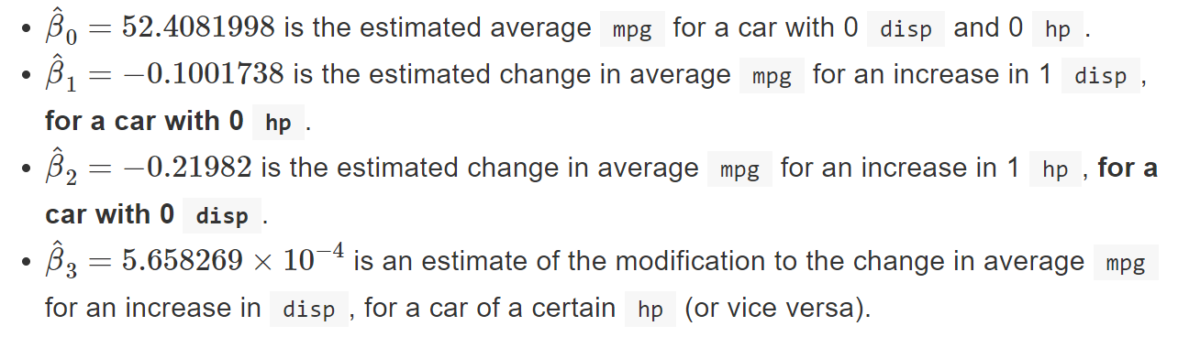

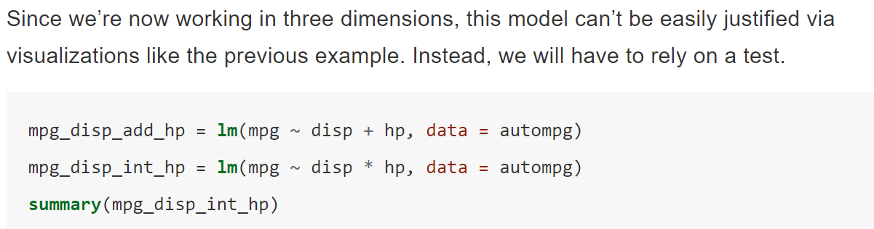

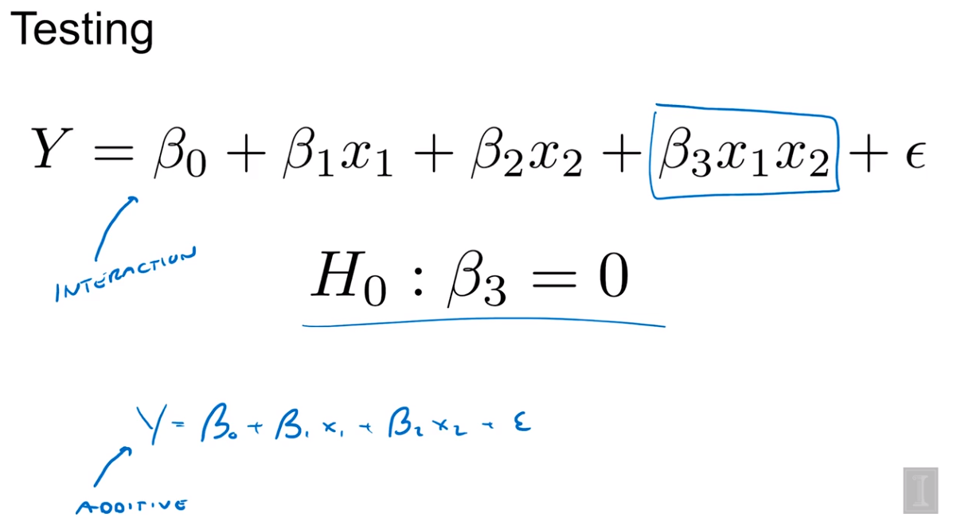

## 11.3 Factor Variables

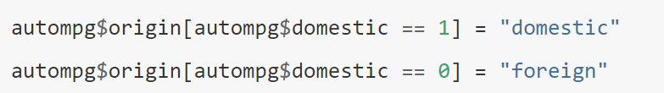

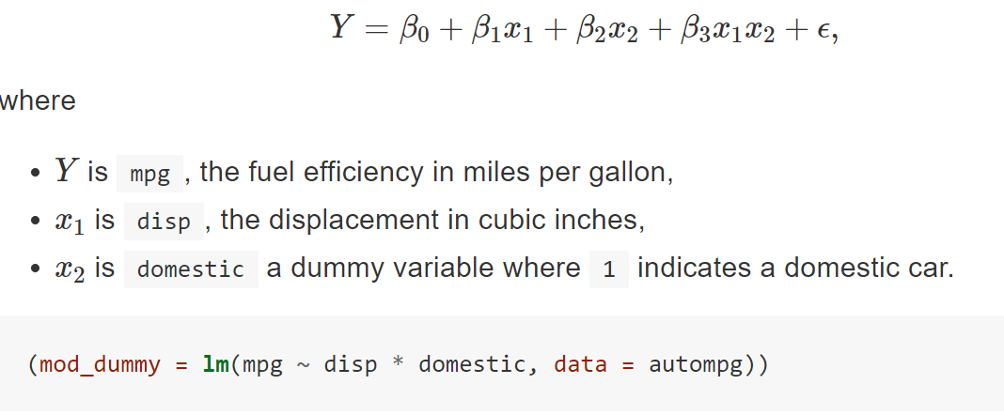

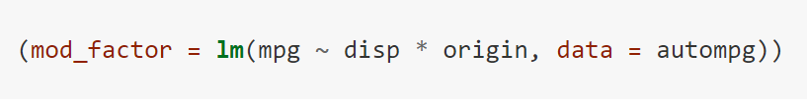

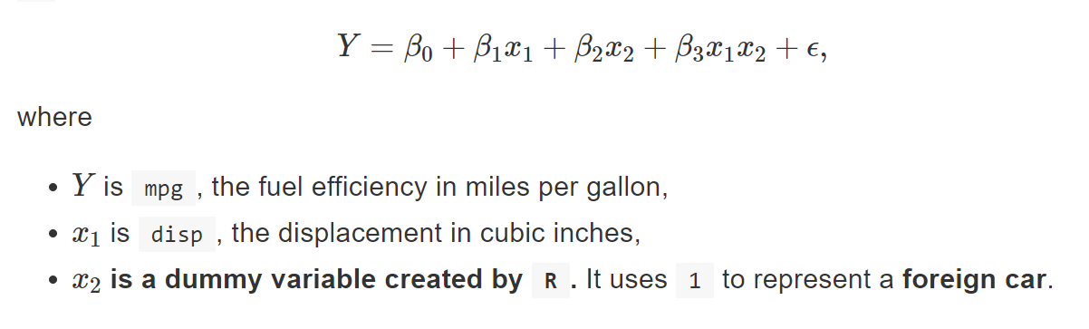

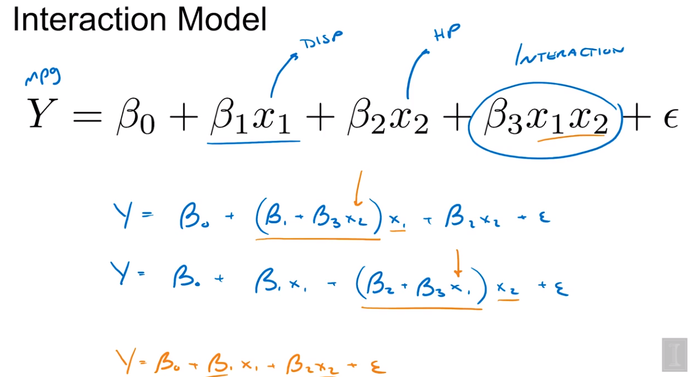

### 11.3.1 Factors with More Than Two Levels

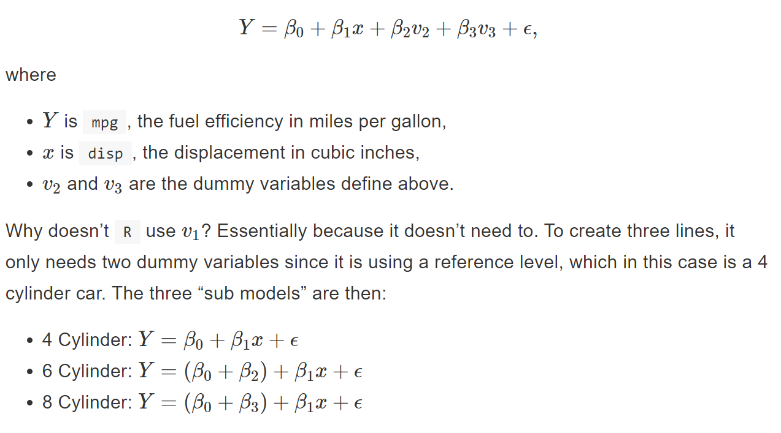

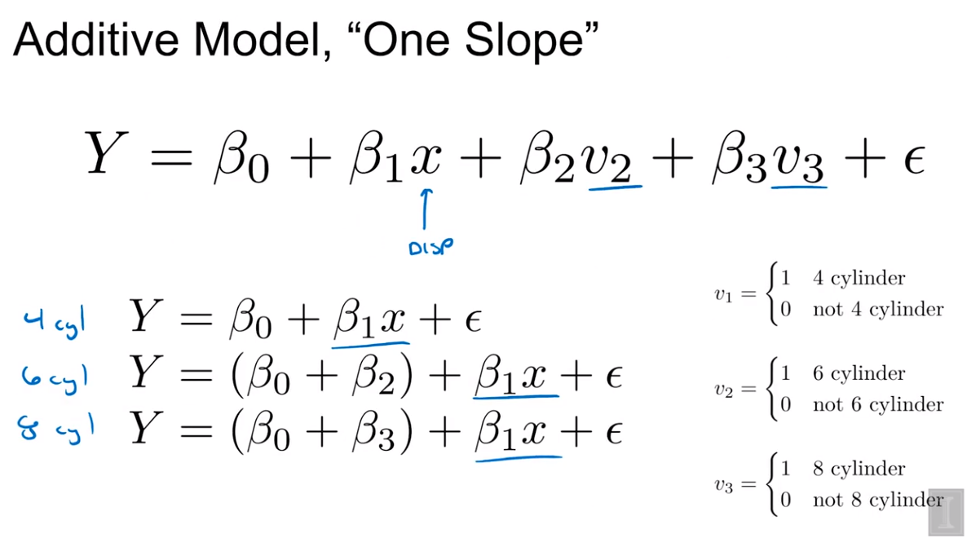

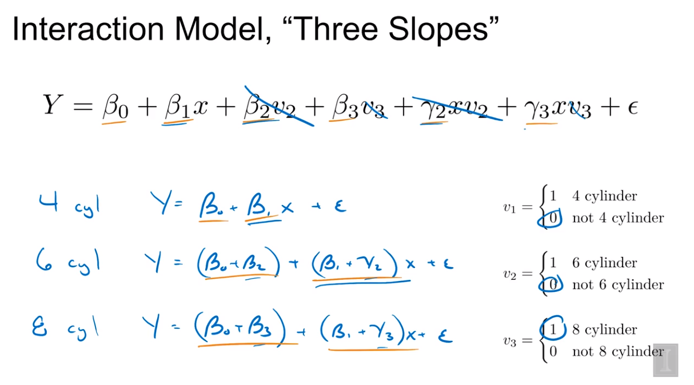

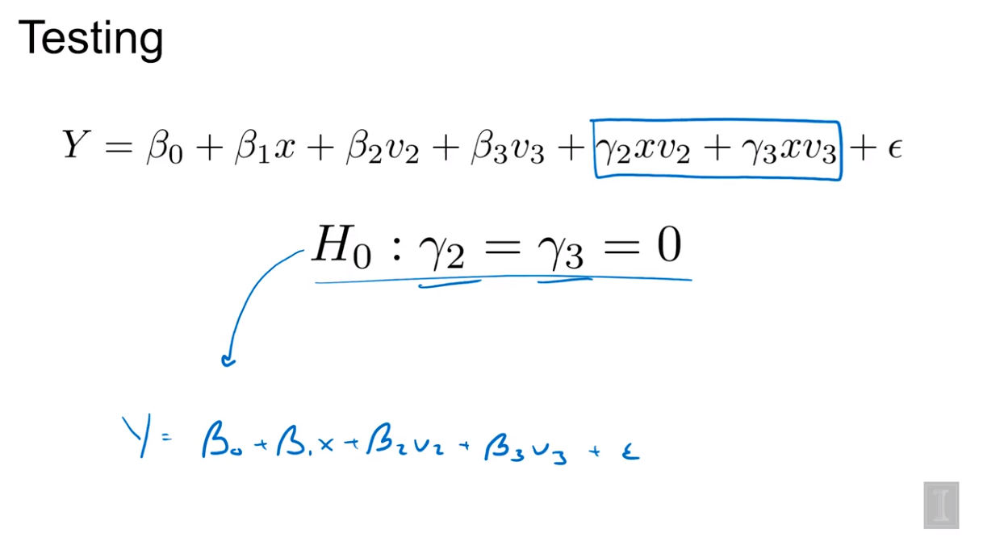

## 11.4 Parameterization

Beta two in our original parametrization was a difference in the intercept between a four cylinder car

 and a six cylinder car whereas in this new parametrization mu two is just directly the intercept for that six cylinder car.

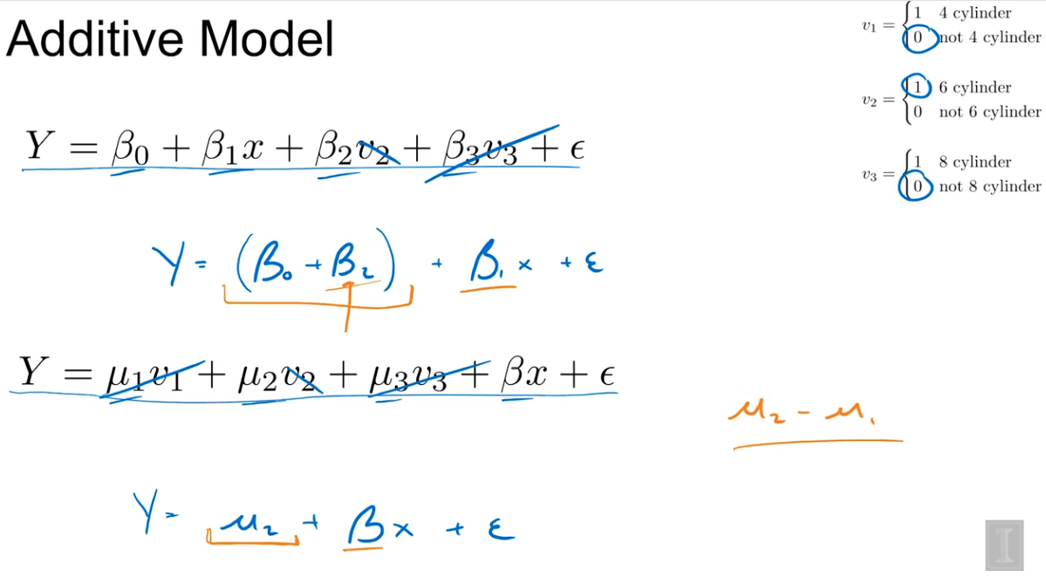

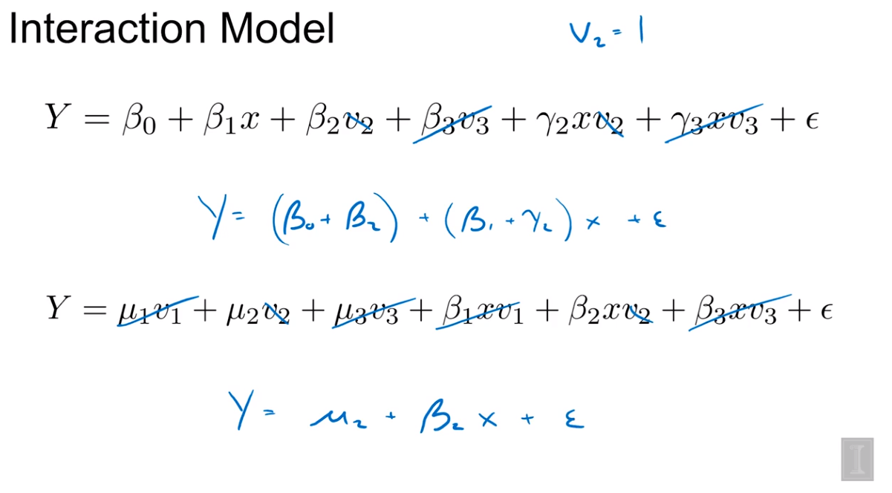

 Relevant to a reference level vs direct

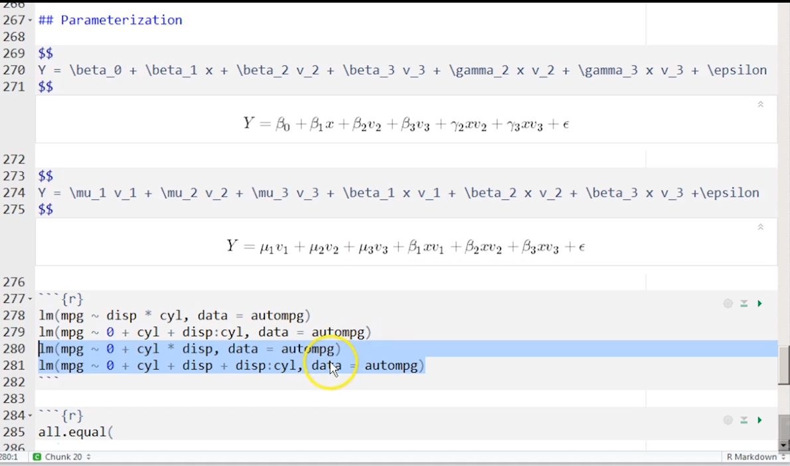

Week 8

